BLG 368E- Operations Research
Midterm Questions (2016)
Dr. Serkan Türkeli
Question 1 (50 Points):
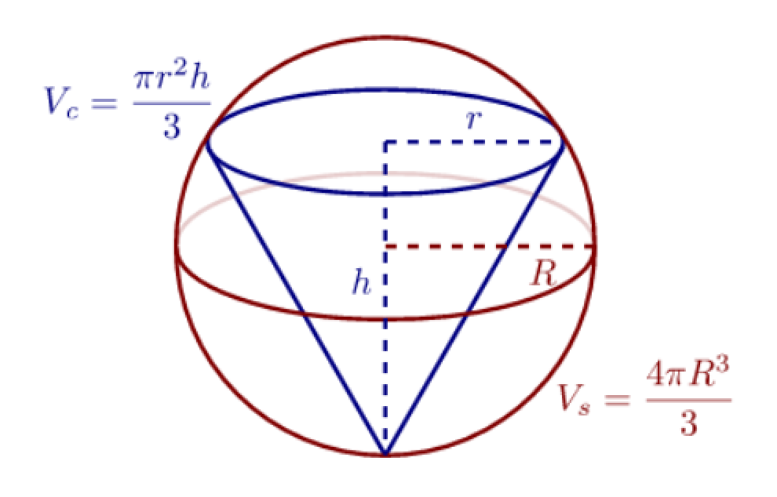

Define objective, constraints, variables and find the largest possible cone inside a sphere (Hint: You can assume that R=4)
Question 2 (35 Points):: Table 1 shows the student interest in control and automation engineering courses. Table 2 shows the academician interest in control and automation engineering courses. Thesis supervisors should have the same number of students according to regulation at ITU. Assign students to academician based on increasing performance as much as possible (Assign one student to one academician).
Table 1:
 | Optimal | KST | EKS | Servo
Burak Kıral | 4 | 3 | 6 | 4
Okan Erol | 9 | 4 | 7 | 4
Kemal Çiçek | 8 | 4 | 4 | 2
Kenan Kaan Kurt | 8 | 5 | 2 | 6
Cihad Doğan | 3 | 6 | 8 | 3
Emre Türkel | 10 | 4 | 10 | 6
Arzuman Can Kutlucan | 10 | 5 | 10 | 9
Mehmet Kabil Gültekin | 2 | 6 | 10 | 8
Muratcan Uztemur | 5 | 10 | 3 | 7
Özgür Erbulan | 8 | 9 | 8 | 8
Ozan Özay | 5 | 10 | 9 | 3
Murat Eroğlu | 2 | 2 | 5 | 10
Anıl Yılmaz | 5 | 3 | 3 | 3
Cansu Önen | 6 | 4 | 10 | 6
Berkan Uzunoğlu | 9 | 8 | 3 | 4
Mustafa Arıcı | 6 | 10 | 5 | 2
Hasan Tekin | 3 | 5 | 10 | 9
Barış Özdemir | 4 | 8 | 8 | 3
Müzeyyen Seda Erciyes | 8 | 7 | 8 | 5
Müge Ateşova | 7 | 9 | 10 | 2

Table 2:
 | Optimal | KST | EKS | Servo
İbrahim Eksin | 9 | 7 | 7 | 5
Metin Gökaşan | 5 | 5 | 6 | 8

Question 3 (50 Points)::
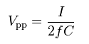
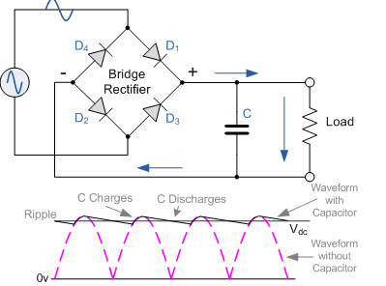
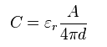

In the figure above there is an example rectifier circuit that is used in a factory. 21 of these rectifiers are needed in that factory for making ripple test in a new product. The manager asked you to make 21 capacitors for each rectifier circuit with different capacitances. The sum of 21 ripple will result in a total ripple of V_{pp}= 1 [Volts]. What will be distances between capacitor plates (d) for each capacitor? (Do Not Change Units) (Hint: Z=1)
Note: Line voltage is 220V, 50 Hz and all parts are ideal.

Name | Load  MΩ | Plate Areas | Dielectric Matter Name | Dielectric Constant  ε | Max Allowed Distance  dmax
Circuit 1 | 349 | 2 | Vacuum | 1,00 | 8
Circuit 2 | 201 | 3 | Air | 1,00 | 3
Circuit 3 | 324 | 8 | Teflon | 4,20 | 4
Circuit 4 | 463 | 7 | Polyisobutylene | 4,24 | 14
Circuit 5 | 494 | 5 | Mineral Oil | 4,49 | 1
Circuit 6 | 301 | 1 | Polyethylene | 4,55 | 20
Circuit 7 | 238 | 9 | Polystyrene | 2,60 | 14
Circuit 8 | 248 | 3 | Kraft Paper | 2,90 | 12
Circuit 9 | 401 | 5 | Table Salt | 7,00 | 8
Circuit 10 | 293 | 6 | Polycarbonate | 4,23 | 13
Circuit 11 | 422 | 10 | Paper | 4,42 | 16
Circuit 12 | 408 | 9 | Silicon dioxide | 4,25 | 5
Circuit 13 | 339 | 6 | FR4 | 4,23 | 18
Circuit 14 | 331 | 5 | Concrete | 4,25 | 1
Circuit 15 | 200 | 2 | Glass | 4,70 | 4
Circuit 16 | 256 | 3 | Halowax | 4,20 | 16
Circuit 17 | 486 | 2 | Cl Diphenyl | 4,24 | 3
Circuit 18 | 328 | 7 | Ruby Mica | 7,10 | 10
Circuit 19 | 288 | 8 | Diamond | 5,90 | 5
Circuit 20 | 468 | 4 | Rubber | 7,00 | 7
Circuit 21 | 233 | 2 | Aluminum Oxide | 4,50 | 16

Question 4(15 Points)::
Fıccın is a local restaurant located in Beyoglu. Fıccın offers Gabın, Velibah, Tulen, and Kopoglu. Each variety has its own requirement coded as X1, X2, X3,X4, X5 (in ounces, as shown in the table), and each has its own selling price. Fıccın has 200 ounces of X1, 90 ounces of X2, 120 ounces of X3, 75 ounces of X4 and 40 ounces of X5. Fıccın is selling a Gabın for 8 TL, Valibah for 10 TL, Tulen for 12 TL, Kopoglu for 15 TL.
 | Gabın | Velibah | Tulen | Kopoglu
Ingredients
X1 | 5 | 5 | 5 | 5
X2 | 3 | 3 | 3 | 3
X3 | 4 | 3 | 3 | 4
X4 | 0 | 3 | 0 | 2
X5 | 0 | 0 | 3 | 2

What is the maximum sales revenue?

