Uniaxial Minerals

UNIAXIAL OPTICS
Uniaxial minerals have only one optic axis, and belong to the hexagonal and tetragonal systems.
Minerals in this group include:
- nepheline NaAlSiO₄
- apatite Ca₅(PO₄)₃(F,Cl,OH)
- calcite CaCO₃
- dolomite (Ca,Mg)CO₃
- quartz SiO₂
- zircon ZrSiO₄
- tourmaline - borosilicate
In the last lab you examined the calcite rhomb and the two rays formed by the light travelling through the rhomb, with each ray corresponding to a different RI of the calcite.
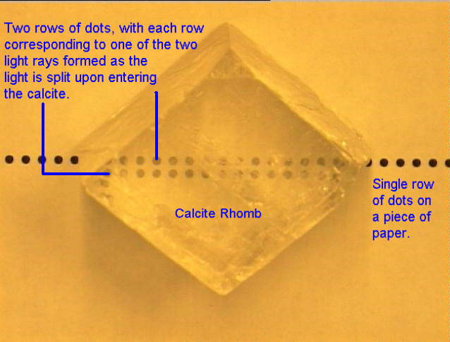
On rotating the calcite rhomb one dot remained stationary but the other dot rotated with the calcite about the stationary dot.
- The ray corresponding to the image which moved is called the Extraordinary Ray - epsilon.
- The ray corresponding to the stationary image, which behaves as though it were in an isotropic mineral is called the Ordinary Ray - omega.
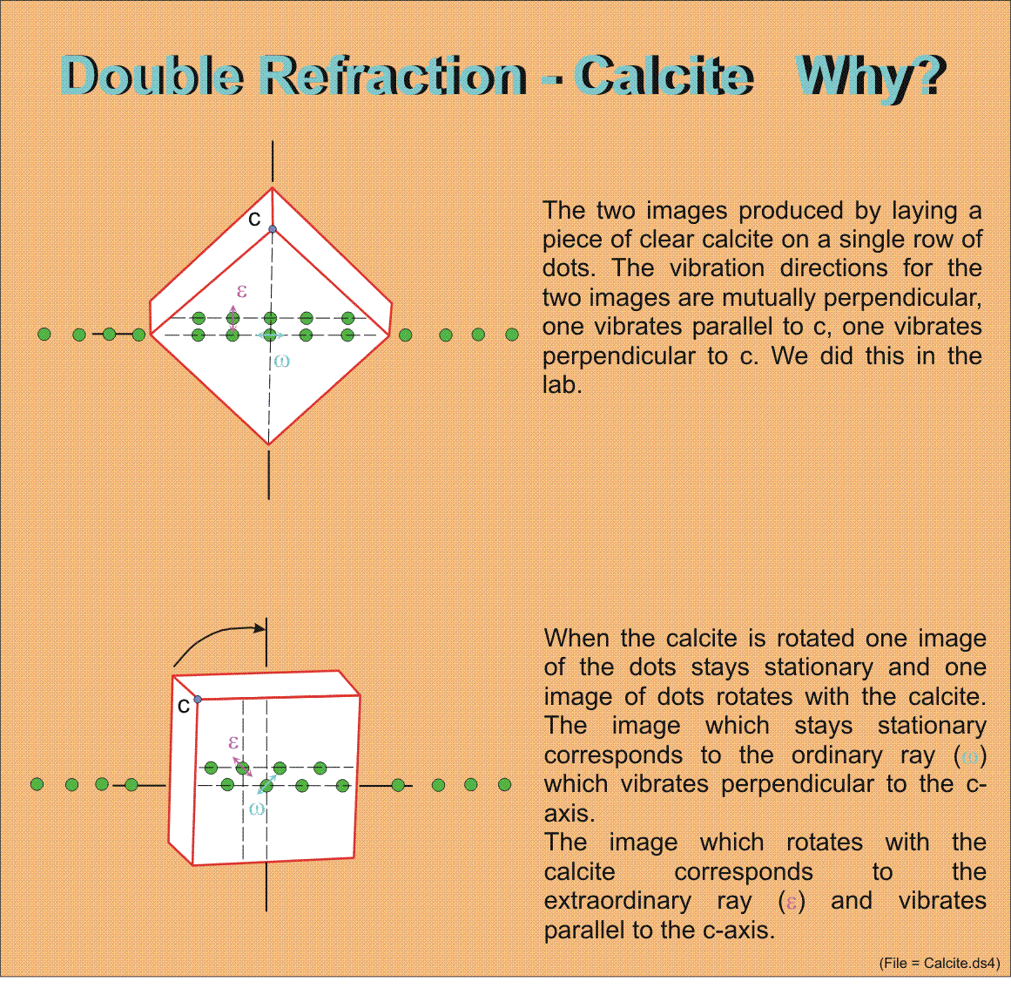
The vibration direction of the ordinary ray lies in the {0001} plane of the calcite and is at right angles to the c-axis.
The extraordinary ray vibrates perpendicular to the ordinary ray vibration direction in the plane which contains the c-axis of the calcite.
If instead of using a calcite rhomb we had used a slab of calcite which had been cut in a random orientation and placed that on the dots, two images would still appear.
If the random cuts were such that they were perpendicular to the c-axis, then light travelling through the calcite, along the c-axis would produce only one image andwould not become polarized.
The c-axis coincides with the optic axis, which is the direction through the mineral along which light propogates without being split into two rays.
For calcite,
- The index of refraction for the ordinary ray is uniform n_{omega} = 1.658, regardless of the direction through the grain that the light follows.
- The index of refraction for the extraordinary ray, n_{epsilon}, is variable ranging from 1.486 to 1.658. The index is dependant on the direction that the light travels through the mineral.
  - If light travels perpendicular to c-axis, n_{epsilon} = 1.486.
  - If the light travels along the the c-axis, n_{epsilon} = 1.658.
  - For intermediate directions through the grain n_{epsilon} will fall between the two extremes.
Calcite is used as an example of the formation of the two rays because of the large difference between the refractive indices (birefringence (delta)).
- for calcite, delta = 0.172.
For minerals with a lower birefringence, e.g. quartz, delta = 0.009, the two images are still produced but show very little separation. The quartz would have to be 20-25X as thick as the calcite to see the same separation of the dots.

UNIAXIAL OPTIC SIGN
In Calcite n_{omega} > n_{epsilon}, 1.658 versus 1.485. In other minerals, e.g. quartz, n_{omega} < n_{epsilon} , 1.544 versus 1.553.
This difference in this refractive index relationship provides the basis for defining the optic sign of uniaxial minerals.
- Optically positive uniaxial minerals n_{omega} < n_{epsilon}
- Optically negative uniaxial minerals n_{omega} > n_{epsilon}
Alternatively,
- if extrordinary ray is the slow ray, then the mineral is optically positive.
- if extraordinary ray is the fast ray, then the mineral is optically negative.
n_{epsilon} refers to the maximum or minimum index of refraction for the extraordinary ray, the value recorded in the mineral descriptions in the text.
n_{epsilon}' refers to an index of refraction for the extraordinary ray which is between n_{omega} and n_{epsilon}.
For uniaxial minerals any orientation will provide n_{omega}, but only one orientation, cut parallel to the c-axis will yield n_{epsilon} maximum. This orientation is the one which exhibits the highest interference colour as delta (birefringence), is greatest, and therefore retardation (DELTA) is greatest.
(DELTA = d(n_{s}-n_{f}))

LIGHT PATHS THROUGH UNIAXIAL MINERALS
n_{epsilon} refers to the maximum or minimum index of refraction for the extraordinary ray, the value recorded in the mineral descriptions in the text.
n_{epsilon}' refers to an index of refraction for the extraordinary ray which is between n_{omega} and n_{epsilon}.
For uniaxial minerals any orientation will provide nw, but only one orientation, cut parallel to the c-axis will yield n_{epsilon} maximum. This orientation is the one which exhibits the highest interference colour as delta (birefringence), is greatest, and therefore DELTA (retardation) is greatest
(DELTA = d(n_{s}-n_{f}))
Hexagonal and tetragonal systems are characterized by a high degree of symmetry about the c-axis. Within the 001 or 0001 plane, at 90° to the c-axis, uniform chemical bonding in all directions is encountered.
Light Paths Through a Mineral
Light travelling along the c-axis is able to vibrate freely in any direction within the 001 or 0001 plane.
No preferred vibration direction allows light to pass through the mineral as if it were isotropic, this orientation has the lowest interference colour - black to dark grey.
If the light passes at some angle to the c-axis, it encounters a different electronic configuration and is split into two rays of different velocities.
The vibration vector of the ordinary ray is parallel to the 001 or 0001 plane, i.e. perpendicular to the c-axis. The extraordinary ray vibrates across these planes, parallel to the c-axis.
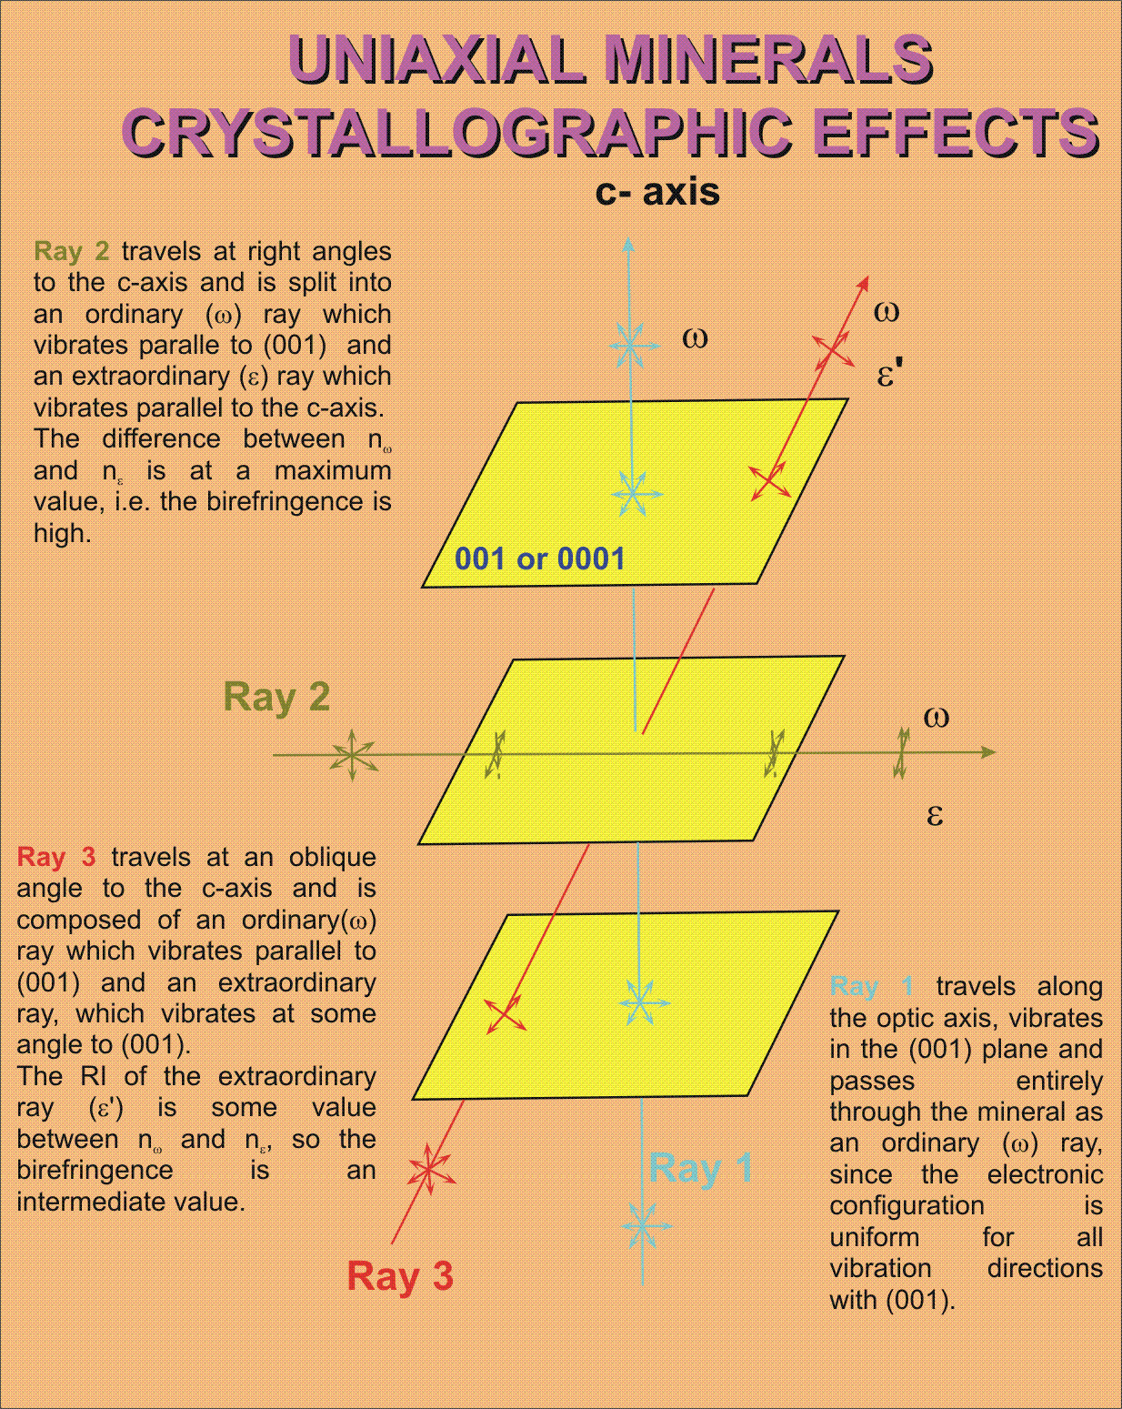

The ordinary ray has the same velocity regardless of the path it takes, because it always vibrates in the same electronic environment.
The extraordinary ray velocity varies depending on the direction. If the light travels nearly parallel to the c-axis, the extraordinary ray vibrates ~ parallel to 001 or 0001, so that n_{epsilon}'~n_{omega}.
If the light travels at right angles to the c-axis, the extraordinary ray vibrates across the 001 or 0001 plane and n_{epsilon} is most different from n_{omega}.
For intermediate angles to the c-axis:
- n_{omega} > n_{epsilon}'
- and, n_{epsilon}' > n_{epsilon}.
Whether the extraordinary ray has a higher or lower RI than the ordiniary ray depends on the chemical bonding and the crystal structure.
In the lab you will determine the indices of refraction for a uniaxial mineral using grain mounts and the immersion method.

UNIAXIAL INDICATRIX
The indicatrix is a geometric figure, constructed so that the indices of refraction are plotted as radii that are parallel to the vibration direction of light.
In isotropic minerals the indicatrix was a sphere, because the refractive index was the same in all directions.
In uniaxial minerals, because n_{omega} and n_{epsilon} are not equal, the indicatrix is an ellipsoid, the shape of which is dependant on its orientation with respect to the optic axis. In positive uniaxial minerals, the Z indicatrix axis is parallel to the c-crystallographic axis and the indicatrix is a prolate ellipsoid, i.e. it is stretched out along the optic axis.
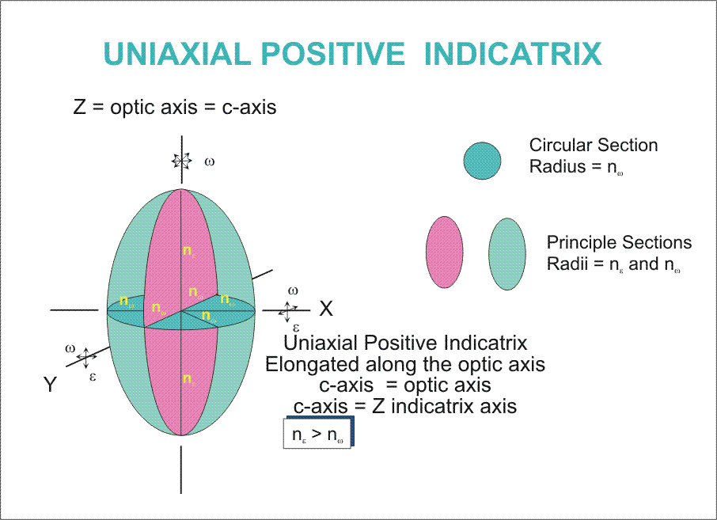
All light travelling along the Z axis (optic axis), has an index of refraction of n_{omega}, whether it vibrates parallel to the X or Y axis, or any direction in the XY plane.
Light travelling along the X axis is split into two rays, the ordinary and extraordinary rays,
- omega vibrates parallel to the Y axis, n_{omega} is plotted along Y
- epsilon vibrates parallel to the Z axis, n_{epsilon} is plotted along Z.
The XZ and the YZ planes through the indicatrix are identical ellipses with n_{omega} and n_{epsilon} as their axes, with the radii of the ellipses equal to the magnitude of the RI for the ray.
Plotting the indices of light travelling in all directions produces the prolate ellipsoid, whose axis of revolution is the optic axis, for uniaxial positive minerals;
n_{omega} < n_{epsilon}.
For optically negative minerals the X indicatrix axis corresponds to the optic axis and the indicatrix is an oblate ellipsoid, i.e. flattened along the optic axis, and
n_{omega} > n_{epsilon}
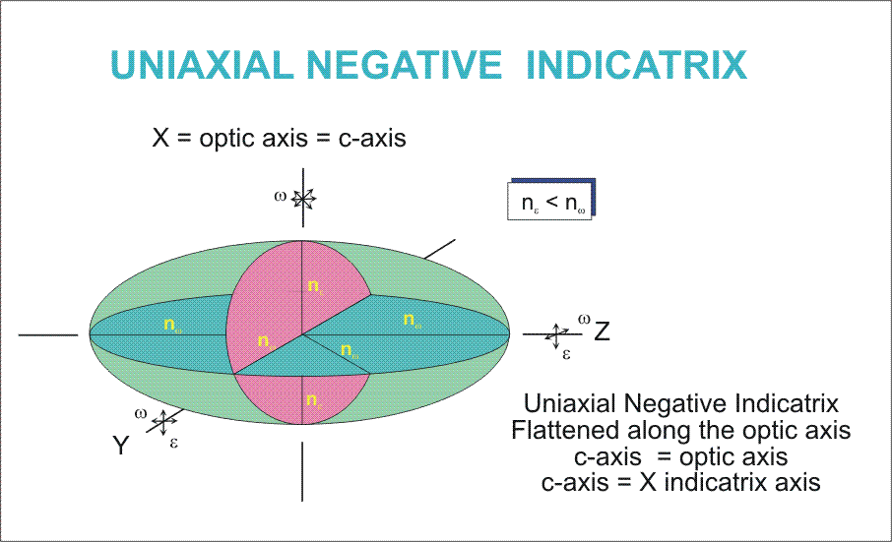
In each case, for positive and negative minerals the circular section through the indicatrix is perpendicular to the optic axis and has a radius = n_{omega}.
The radius of the indicatrix along the optic axis is always n_{epsilon}.
Any section through the indicatrix which includes the optic axis is called a principal section, and produces an ellipse with axes n_{omega} and n_{epsilon}.
A section through the indicatrix perpendicular to the optic axis produces a circular section with radius n_{omega}.
A random section through the indicatrix will produce an ellipse with axes n_{omega} and n_{epsilon}'.
The indicatrix is oriented so that the optic axis is parallel to the c crystallographic axis.

Random Section Vibration Directions
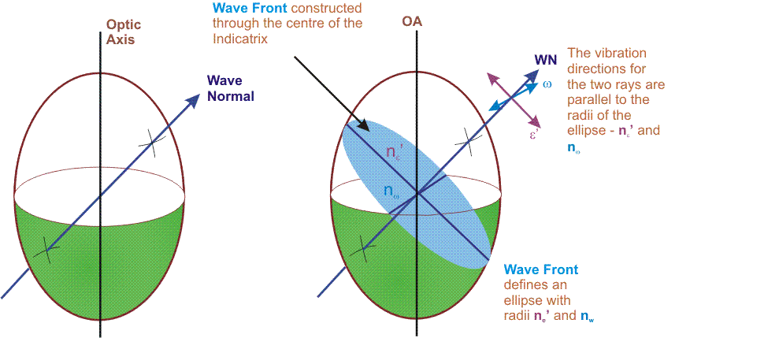
Random section through the uniaxial indicatrix will give n_{omega} and n_{epsilon}'.
Light travelling from the origin of the indicatrix outwards, construct a wave normal to the wave front.
A slice through the centre of the indicatrix, perpendicular to the wave normal forms an ellipse with axes of n_{omega} and n_{epsilon}'.
- omega vibrates at 90° to the optic axis = short axis of the ellipse
- epsilon' vibrates parallel to the optic axis = long axis of the ellipse.
The magnitude of the axes = n_{omega} and n_{epsilon}'.

BIREFRINGENCE AND INTERFERENCE COLOURS
Birefringence, difference between the index of refraction of the slow and fast rays and the interference colours for uniaxial minerals is dependant on the direction that light travels through the mineral.
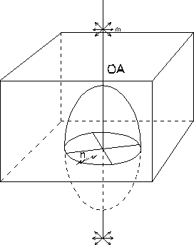
- In a sample which has been cut perpendicular to the optic axis, the bottom and top surfaces will be parallel. The angle of incidence for the light entering the crystal = 0° and the wave front are not refracted at the interface and remain parallel to the mineral surface.
  - A cut through the indicatrix, parallel to the bottom of the mineral, will yield the indices and vibration directions of the light. A slice through the indicatrix is a circular section, with radius n_{omega}.
  - No preferred vibration direction, so light passes along the optic axis as an ordinary ray and retains whatever vibration direction it had originally.
  - Between crossed polars the light passing through the mineral is completely absorbed by the upper polar and will remain black on rotation of the stage, The birefringence = 0.
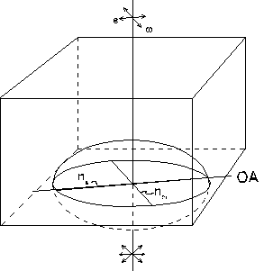
- Cutting the sample such that the optic axis is parallel to the surface of the section the following is observed.
  - The indicatrix section is a principle section, as it contains the optic axis. The indicatrix forms an ellipse with axes = n_{omega} and n_{epsilon}, with the incident light being split into two rays such that:
    - the ordinary ray vibrates perpendicular to the optic axis,
    - the extraordinary ray vibrates parallel to the optic axis.
  - The birefringence is at a maximum, and in thin section this grain orientation will display the highest interference colour.
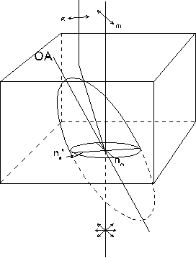
- A mineral cut in a random orientation, with normally incident light;
  - The ordinary ray produced has an index, n_{omega} and vibrates perpendicular to the optic axis.
  - The extraordinary ray has an index n_{epsilon}' and vibrates in the plane containing the optic axis.
  - n_{epsilon}' < n_{omega} maximum or minimum, the birefringence is intermediate between the two extremes.

EXTINCTION IN UNIAXIAL MINERALS
Uniaxial minerals will exhibit all four types of extinction discussed earlier.
The type is dependent on:
- the orientation that the mineral is cut
- the presence of cleavage(s) in the grain

Tetragonal minerals
- Zircon ZrSi0₄- poor prismatic
- Rutile Ti0₂ - good prismatic
  - are prismatic and either elongate or stubby II to c axis.
  - display prismatic (parallel to c)
  - or pinacoidal (perpendicular to c) cleavage.
Depending on how the crystal is cut, and how its indicatrix is cut, dictates what will be seen in thin section.

Hexagonal Minerals
- Quartz - SiO₂ - no cleavage
- Apatite - Ca₅(PO₄)₃(F,C1,OH) - rare pinacoidal, prism
- Calcite - CaC0₃ - 1 of two cleavages rhombohedral
- Nepheline - NaAlSiO₄ - no cleavage
Hexagonal minerals will exhibit the following forms prisms, pinacoids, pyramids and rhombohedrons which will exhibit prismatic, pinaciodal and rhombohedral cleavages.
The birefringence, interference colours and any cleavage displayed by hexagonal minerals is a function of how the grain has been cut.

PLEOCHROISM IN UNIAXIAL MINERALS
Pleochroism is defined as the change in colour of a mineral, in plane light, on rotating the stage. It occurs when the wavelengths of the ordinary & extraordinary rays are absorbed differently on passing through a mineral, resulting in different wavelengths of light passing the mineral.
Coloured minerals, whether uniaxial or biaxial, are generally pleochroic.
To describe the pleochroism for uniaxial minerals must specify the colour which corresponds to the ordinary and extraordinary rays.
- e.g. Tourmaline, Hexagonal mineral
  - omega = dark green
  - epsilon = pale green
If the colour change is quite distinct the pleochroism is said to be strong.
If the colour change is minor = weak pleochroism.
For coloured uniaxial minerals, sections cut perpendicular to the c axis will show a single colour, corresponding to ordinary ray.
Sections parallel to the c crystallographic axis will exhibit the widest colour variation as both omega and epsilon are present.

OBTAINING AN INTERFERENCE FIGURE
Now come to the major means of distinguishing whether an anisotropic mineral is uniaxial or biaxial and for determining the optic sign for an anisotropic minerals - THE INTEFERENCE FIGURE.
To obtain and observe an interference figure using the microscope.
- With high power, focus on a mineral grain free of cracks and inclusions
- Flip in the auxiliary condensor and refocus open aperture diaphragm up to its maximum.
- Cross the polars
- Insert the Bertrand lens or remove the ocular and look down the microscope tube.
Will not see the grain, but the interference figure, which appears on the top surface of the objective lense.

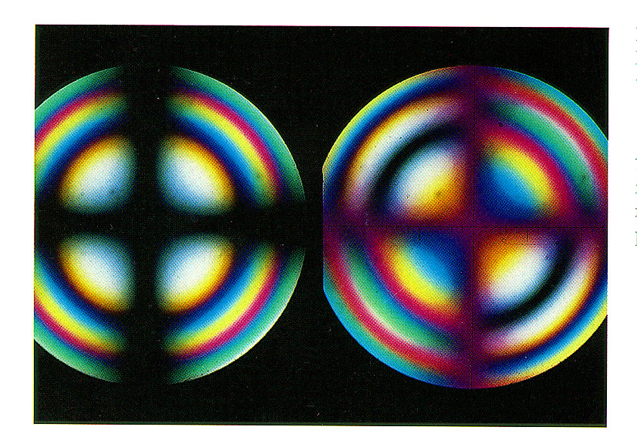
The interference figure consists of a pattern of interference colours and a black band which may form a cross. Nature and pattern for the figure is dependent on the orientation of the grain.
For Uniaxial Minerals three types of interference figures will be considered.
- Optic Axis Figure - OA vertical
- Off Centred Optic Axis Figure - OA inclined.
- Flash Figure - OA horizontal
Each figure type is a direct reflection of the different cuts through the indicatrix.

OPTIC AXIS INTERFERENCE FIGURE
If the optic axis of the mineral is vertical, the grain will exhibit 0 birefringence and remain black or nearly black upon rotating the stage.
The interference figure produced by such a grain is a centred optic axis figure which consists of a centred black cross superimposed on circular bands of interference colours.
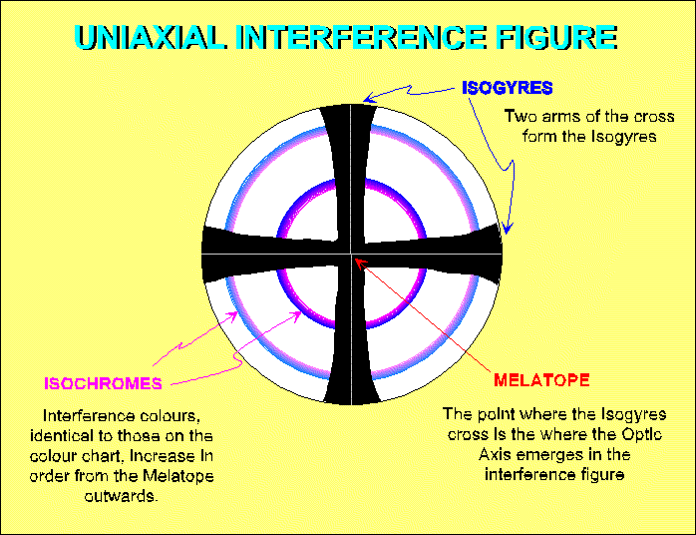
The cross is formed of black bars - isogyres, point where the two isogyres cross is the melatope and marks the point where the optic axis emerges.
Interference colours increase in order outward from the melatope, near melatope colours are low first order Each colour band is called an isochrome.
If the optic axis is vertical the interference figure for the mineral does not move as the stage is rotated.
Isochromes form and are exhibited by the interference figure due to varying retardation of convergent light rays on the sample.

FORMATION OF ISOCHROMES
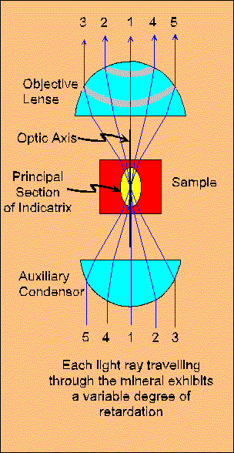
Light is convergent because auxiliary condensor produces a cone of light which is focused on the sample, it passes through the sample and is collected by the objective lens.
- Light which travels along the optic axis is not split into two rays, n_{epsilon}' = n_{omega}, and exits the mineral to form the melatope. No retardation "between" rays.
- Light following paths 2 & 4 experience moderate retardation
n_{epsilon}' < n_{omega} ~ 550 nm
- Light following paths 3 & 5 experience moderate retardation
n_{epsilon}' << n_{omega} ~ 1100 nm because light makes a larger angle with optic axis and must take a longer path through the sample.
Optic axis is vertical and optical properties vary symmetrically about the optic axis, rings of equal retardation are produced around the melatope = isochromes.
Number of isochromes depends on retardation and the thickness of the sample.
Simplified, ignored the splitting of light into its two component rays, each of which refract differently.

FORMATION OF ISOGYRES
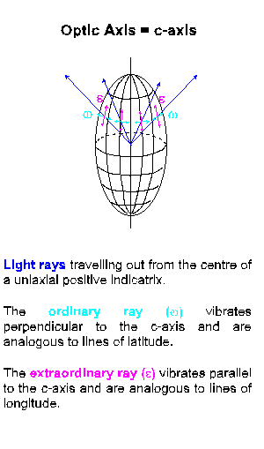
Isogyres form when the vibration directions in the interference figure parallel the vibration directions of the polars. These are areas of extinction.
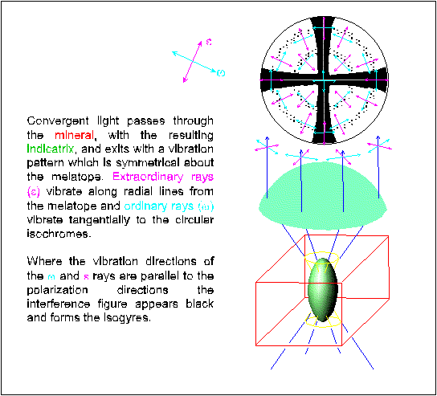
In the uniaxial indicatrix the ordinary rays vibrate perpendicular to the optic axis and are analogous to lines of latitude on the surface of the indicatrix. They vibrate as tangents to the circular isochromes.
Extraordinary rays vibrate parallel to the optic axis and are analogous to lines of longitude on the indicatrix surface and vibrate along radial lines from melatope outwards.
Once the interference figure has been obtained and identified as to whether it is uniaxial or biaxial, the optic sign of the mineral can be determined using an accessory plate, either gypsum, quartz or mica.

OPTIC SIGN DETERMINATION
Once the interference figure has been obtained and identified as to whether it is uniaxial or biaxial, the optic sign of the mineral can be determined using an accessory plate, either gypsum, quartz or mica.
The optic sign tells us whether the ordinary ray corresponds to the fast or slow ray.
omega = Fast | Optically Positive | epsilon = Slow
omega = Slow | Optically Negative | epsilon = Fast
To determine optic sign of a uniaxial mineral:
- Obtain an optic axis interference figure.
one that is centred in field of view
- Insert accessory plate into the light path.
- Observe the interference colours:
  - in two quadrants the colours increase, move to the right,
  - in other two quadrants the colours decrease, move to the left.
- Look at the NE quadrant of the interference figure.

INTERPRETATION
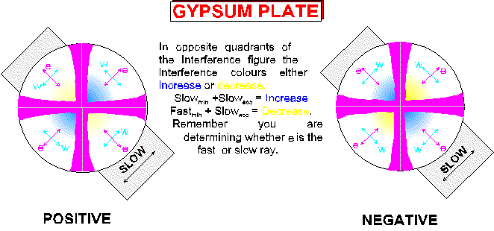
In the centred uniaxial optic axis interference figure, remember;
- omega vibrates parallel to isochromes
- epsilon vibrates radially from centre
The accessory plate vibration direction is NE - SW, and corresponds to slow direction of plate. It is parallel to extraordinary ray vibration direction in NE Quadrant of the interference figure.
Examining the NE quadrant of the interference figure, two possibilities may occur:
- The interference colours will increase, move to the right on the colour chart, when the accessory plate is inserted. This tells us that the extraordinary ray, of the mineral, must be the slow ray and therefore the mineral is optically positive.
- The interferecne colours will decrease, move to the left on the colour chart, when the accessory palte is inserted. This tells us that the extraordinary ray, of the mineral, must be the fast ray and therefore the mineral is optically negative.
The SW quadrant og the interference figure will exhibit the same colour changes, observed in the NE quadrant because omega and epsilon vibration directions are the same.
The NW & SE quadrants exhibit the reverse colour changes.
Gypsum Plate is used to determine the optic sign, provided not too many isochromes are present.

OPTIC SIGN USING THE GYPSUM PLATE
Under crossed polars, without the gypsum plate, a first order grey interference colour has a retardation of approximately 200 nm.
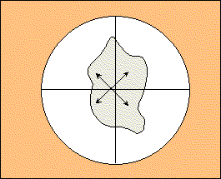
This first order grey colour, on inserting the gypsum plate, will either;
- Increase to second order blue-green, the colour shown on the left below,
(200 + 550 =750 nm)
giving a total retardation = 750 nm
or
- Decrease to first order yellow, the colour shown on the right below,
(200-550 |-350| nm)
giving a total retardation = 350 nm.
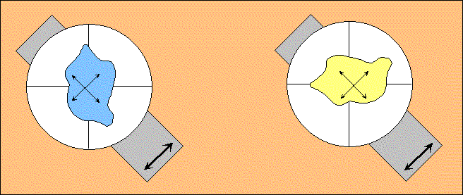
The blue or green colour results from the addition of the slow vibration direction of plate to the slow vibration direction of mineral.
The yellow colour results from the subtraction of the slow vibration direction of plate from the fast vibration direction of mineral.

OPTIC SIGN USING THE QUARTZ WEDGE
If the interference figure displays numerous isochromes colour changes produced with the gypsum plate become difficult to detect. In this case the quartz wedge is used.
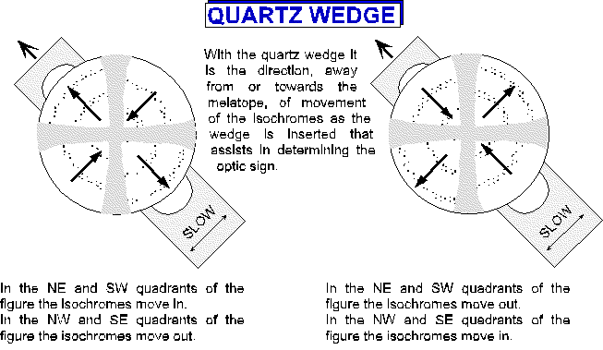
Inserting the Qtz wedge results in the movement of the isochromes about the isogyres.
In quadrants where the colours subtract, i.e. where the fast ray of the mineral is parallel to slow ray direction of the quartz wedge, the isochromes move outward as lower order colours form near the melatope and displace higher order colours.
In quadrants where the colours add, where the slow ray of the mineral is parallel to the slow ray of the quartz wedge, the isochromes move inwards, towards the melatope.
The isogyre, on insertion of the accessory adopts the interference colour corresponding to the retardation of the accessory.

OFF CENTRED OPTIC AXIS FIGURE
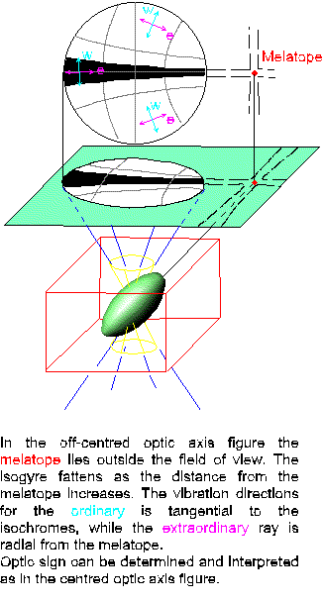
The interference figure is produced when the optic axis is not vertical, resulting in the interference figure, i.e. the melatope, no longer being centred in the field of view.
The isogyres still form a cross, with the melatope at the centre.
Because the figure is off centred, the melatope (optic axis) does not appear in the field of view, on rotation the melatope swings in a circle around the center of the field of view.
Isogyres will retain their basic NS & EW orientations and sweep across the field of view centred on the melatope, always moving parallel to the crosshairs.
If the melatope is just in the field of view the optic sign can easily be determined, using the technique outlined above.

If the melatope is well outside the field of view the isogyres sweep across the field of view in sequence as the stage is rotated - with the isogyres always remaining parallel to the crosshairs.
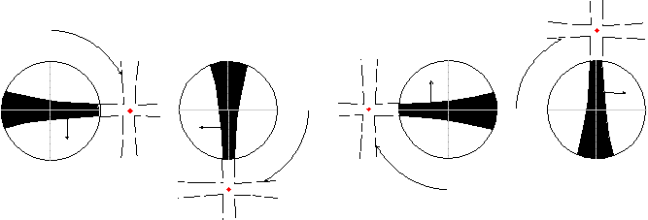
By noting the direction and sequence of how the isogyres pass through the field of view, as the stage is rotated, it is possible to identify which quadrant is being viewed and therefore the optic sign may be determined, knowing the vibration directions of omega & epsilon, in the NE quadrant of the interference figure.
A grain which produces an off centred optic axis figure will exhibit a birefringence intermediate to the maximum and minimum birefringence for that mineral in the thin section.

FLASH FIGURE
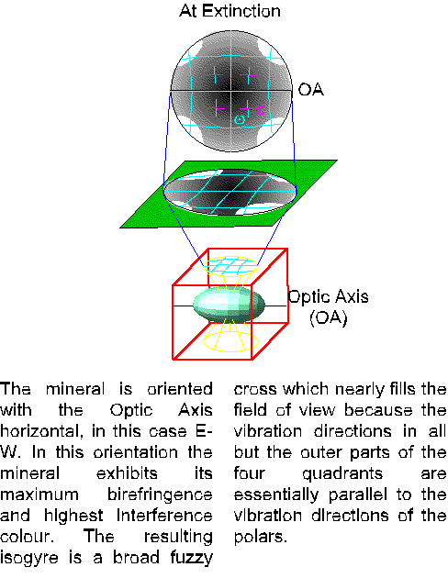
A mineral grain is oriented with it's optic axis horizontal. This orientation exhibits the maximum birefringence, for this mineral in the thin section, and produces a flash figure.
The flash figure results because the vibration directions, of the indicatrix, within the field of view are nearly parallel to polarisation directions of the microscope.
- extraordinary rays vibrate parallel to optic axis
- ordinary rays vibrate perpendicular to optic axis
With the grain at extinction the optic axis is oriented either EW or NS in the resulting interference figure. The interference figure produced occupies most if not all of the field of view and consists of a very broad, fuzzy isogyres cross.
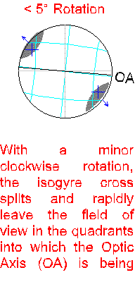
Upon rotating the stage, < 5° rotation, the isogyres will split and move out of the field of view in opposite quadrants.
The quadrants into which the isogyres move correspond to the quadrants into which the optic axis is moving, as the stage is being rotated.
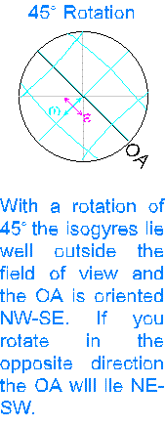
With the optic axis in the 45° position, no isogyres will be present, and the field of view may exhibit some interference colours. Isochromes, if present, will be concave outward.
The colour in the centre of the field of view is the normal interference colour for that mineral under crossed polars.
In quadrants which contain the optic axis, the interference colours decrease away from the centre.
In remaining two quadrants the interference colours increase away from centre.
The number of isochromes observed is dependant on the thickness of the thin section and the birefringence of the specific mineral.
If the central portion of the figure in the 45° position is white, the optic axis quadrants will be first order grey, other quadrants will be pale first order yellow.
Optic sign can be determined using flash figure, but it is not definitive.
Biaxial minerals will also produce a flash figure. It is better to look for a centred or off centred figure, either uniaxial or biaxial to determine the optic sign of the unknown mineral.

SUMMARY OF UNIAXIAL INTERFERENCE FIGURES

Optic axis Figure
The thin section is perpendicular to the c axis = optic axis.
The mineral appears isotropic, or nearly isotropic under crossed polars, exhibiting a very low first order grey to black interference colour.

Off centred Optic Axis Figure
The c axis (optic axis) is not vertical, but inclined from the vertical axis of the microscope.
Will only see isogyre in the field of view at a time, which will sweep out of the field of view parallel to one crosshairs to be replaced by a new isogyre which sweeps into the field of view parallel to the other crosshair.
This orientation will exhibit an intermediate colour, between the lowest and highest colour exhibited by this mineral in the thin section being examined.

Flash Figure
The c axis is parallel to stage.
The isogyres split and leave field of view rapidly with only a slight rotation, <10°.
The maximum interference colour will be observed under crossed polars.

Sign determination
- + ve n_{omega}<n_{epsilon}
slow ray = epsilon, fast ray = omega
- - ve n_{omega}>n_{episilon}
slow ray = omega, fast ray = epsilon.

Uniaxial Minerals - Optical Properties, Descriptions and Pictures

APATITE
General Formula:  Ca₅(PO₄)₃(F,OH,Cl) | Sample: PT-10C | System:  Hexagonal
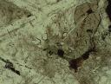 | 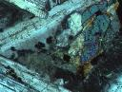 | 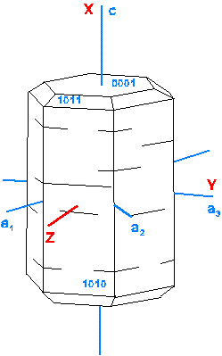
Hexagonal and elongated Apatite needles  Fine grained hexagonal and elongated needles of apatite included in plagioclase and clinopyroxene within an olivine diabase.  The long axis of the image is 0.9 mm, plane light view | Hexagonal and elongated Apatite needles  The hexagonal grains are cross sections of apatite needles, cut perpendicular to the long axis which also corresponds to the c crystallographic axis and the optic axis, thus the needles appear black.  The long axis of the image is 0.9 mm,crossed polar view | Block diagram showing the relationship between the crystallographic axes and the indicatrix axes.

Optical Properties
Colour  Pleochroism | usually colourless  non pleochroic in thin section | Form | small euhedral to subhedral elongate prismatic crystals with hexagonal cross sections are most common, also found as anhedral grains and granular or columnar aggregates
Relief/  RI | moderate high positive  n_{w} = 1.633-1.667  n_{e} = 1.629-1.665 | Cleavage | poor basal and prismatic, not readily visible in thin section
Birefringence  Interference Colours | 0.001 - 0.007  first order grey | Twinning | rare
Interference Figure  Optic Sign  2V | uniaxial  negative | Optic Orientation | elongate sections show parallel extinction and are length fast
Composition | widest variation in composition is associated with the hydroxyl site, e.g. F for OH for Cl | Alteration | stable in most geologic environments
Occurrence | present as an accessory in a wide variety of igneous and metamorphic rocks and as detrital grains in sedimentary rocks | Distinguishing Features | moderate to high relief, low birefringence and uniaxial character

QUARTZ
General Formula:  SiO₂ | Sample: M-20 | System:  Hexagonal (trigonal)
 | 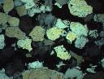 | 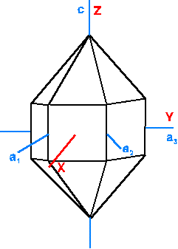
Orthoquartzite  Subrounded quartz grains cemented in a matrix of silica. The grain boundaries are clearly marked by the fine grained inclusions.  Field of View 2.7 mm, plane light | Orthoquartzite  Note the variety of orientations present in the randomly oriented quartz grains.  Field of View 2.7 mm, crossed polars | Block diagram showing the relationship between the crystallographic axes and the indicatrix axes.

Optical Properties
Colour  Pleochroism | colourless  non-pleochroic | Form | typically anhedral to highly irregular in igneous and metamorphic rocks. Detritial grains are are more or less equant.
Relief/  RI | low positive relief  n_{w} = 1.544  n_{e} = 1.553 | Cleavage | not observed
Birefringence  Interference Colours | 0.009  Maximum interference colour range up to first order white, with a tinge of yellow | Twinning | non observed
Interference Figure/  Optic Sign  2V | unixial positive, but strained displaying undulatory extinction may show a biaxial interference figure with a small separation of the isogyres. | Optic Orientation | optic axis is the c axis. Elongate crystals cut from end to end are length slow.
Composition | essentially pure SiO₂, although trace amounts of Ti, Fe, Mn, Al may be present. | Alteration | not readily altered and is very stable in weathering environments.
Occurrence | one of the most widely abundant minerals, present in a wide variety of environments. | Distinguishing Features | low relief, low birefringence, lack of cleavage, uniaxial positive.

CALCITE
General Formula:  CaCO₃ | Sample: M-24 | System:  Hexagonal (trigonal)
 |  | 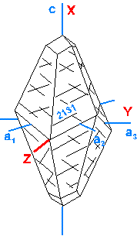
Calcite  Irregular calcite crystals within a marble. Note the rhombohedral cleavage displayed by the grain just left of center.  Field of View = 2.7 mm, plane light | Calcite  Extreme inteference colours of calcite and the presence of twinning in the top right grain.  Field of View = 2.7 mm, crossed polars | Block diagram showing the relationship between the crystallographic axes and the indicatrix axes.

Optical Properties
Colour  Pleochroism | colourless  non pelochroic | Form | variety of habits, but usually coinsist of scalenohedron and rhombohedron combinations. In most rocks calcite forms anhedral grains or grain aggregates
Relief  RI | moderate negative to high positive, marked change with stage rotation  n_{w} = 1.658  n_{e} = 1.486 | Cleavage | perfect rhombohedral cleavage, angle between cleavages 74°57'
Birefringence  Interference Colours | 0.172  extreme, creamy high order colours | Twinning | lamellar twins parallel to one edge of the cleavage rhomb or along the long diagonal of the rhomb
Interference Figure  Optic Sign  2V | uniaxial  negative | Optic Orientation | extinction is inclined or symmetrical to cleavage traces, the fast ray is parallel to the short diagonal of the rhombohedral faces
Composition | dominantly CaCO₃, but substitution of Mg, Fe, Mn, or Zn and minor Sr and Ba | Alteration | altered to dolomite during diagenesis, calcite is soluble in natural waters and may be removed by solution
Occurrence | common and widespread as a major mineral in limestones, and an accessory in igneous, metamorphic and sedimentary rocks | Distinguishing Features | cleavage, variable relief, extreme interference colours

TOURMALINE
General Formula:  Na(Mg,Fe,Li,Al)₃Al₆(Si₆O₁₈)(BO₃)₃(OH,F)₄ | Sample: PT-123 | System:  Hexagonal (trigonal)
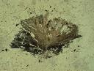 | 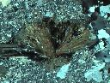 | 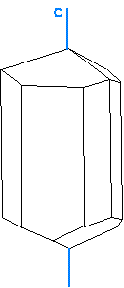
Radiating Tourmaline  The range of pleochroic colours displayed by the radiating tourmaline crystals is evident. Note that the grains exhibit their lightest and darkest pleochroic colour when the long axis is parallel and perpendicluar, respectively, to the lower polar vibration direction (N-S).  Field of View 2.7 mm, plane light | Radiating Tourmaline  The extinction of the individual grains varies across the grain aggregate, when the long axis is parallel to the polars the grain is extinct.  Field of View 2.7 mm, crossed polars | Block diagram showing the relationship between the crystallographic axes and the indicatrix axes.

Optical Properties
Colour  Pleochroism | highly variable, blue, green, pink, yellow  stongly pleochroic with w > e, basal sections are uniformly dark. | Form | euhedral, stubby columnar to acicular crystals with a rounded triangular to crudely hexagonal cross section
Relief  RI | moderate to high positive  n_{w} = 1.631-1.968  n_{e} = 1.610-1.675 | Cleavage | poorly developed, fractures are conchoidal
Birefringence  Interference Colours | 0.015-0.035  up to upper second order, but commonly masked by mineral's colour | Twinning | rare
Interference Figure  Optic Sign  2V | uniaxial  negative | Optic Orientation | longitudinal sections show parallel extinction and are length fast
Composition | highly variable, RI and birefringence increase generally with increasing Fe | Alteration | fairly stable in weathering environments
Occurrence | characteristic mineral in granites and related rocks, in schists, gneisses and phyllites and as a detrital mineral | Distinguishing Features | crystal habit, distinct pleochrosm. Tourmaline exhibits its darkest pleochroic colour when the long axis of the grain is aligned perpendicular to the lower polar.

NEPHELINE
General Formula:  Na₃K(Al₄Si₄O₁₆) | Sample: Nepheline Syenite | System:  Hexagonal
 |  | 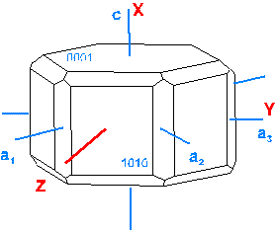
TITLE  DESCRIPTION  SCALE | TITLE  DESCRIPTION SCALE | Block diagram showing the relationship between the crystallographic axes and the indicatrix axes.

Optical Properties
Colour  Pleochroism | colourless  non pleochroic | Form | anhedral to sudhedral in intrusive rocks, subhedral to euhedral in extrusive rocks
Relief  RI | low negative to low positive  n_{w} = 1.529-1.546  n_{e} = 1.526-1.544 | Cleavage | rarely seen in thin section, irregular fractures
Birefringence  Interference Colours | 0.003 - 0.005  first order grey | Twinning | not observed
Interference Figure  Optic Sign  2V | uniaxial  negative | Optic Orientation | longitudinal sections through euhedral crystals as length fast, with parallel extinction
Composition | most nepheline has a 3:1 ratio of Na:K. At high temperatures complete solid solution exists between pure nepheline (100% Na) and kalsilite (100% K) | Alteration | alters to clay minerals, analcime, sodalite, calcite, and cancrinite
Occurrence | common in syenite, nepheline syenite and related alkalic rocks. Nepehiline is never associated with primary quartz. | Distinguishing Features | low relief, looks like quartz but may be altered and is uniaxial negative.

ZIRCON
General Formula:  ZrSiO₄ | Sample: GB 12 | System:  Tetragonal
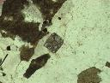 | 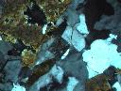 | 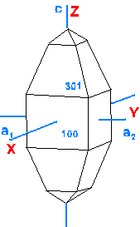
Zircon  Euhedral zircon grain within a granitic gneiss. Note the highly fractured nature of the grain and the very strong relief.  Field of View 1 mm, plane light | Zircon  The same image as that on the left, the high interference colours of the zircon grain are not readily evident in this image,  Field of View 1 mm, crossed polars | Block diagram showing the relationship between the crystallographic axes and the indicatrix axes.

Optical Properties
Colour  Pleochroism | colourless to pale brown  weakly pleochroic | Form | euhedral to sudhedral tetragonal crystals with pyramidal terminations
Relief  RI | very high positive  n_{w} = 1.920-1.960  n_{e} = 1.967-2.015 | Cleavage | not usually seen in thin section
Birefringence  Interference Colours | 0.036-0.065  up to third or fourth order | Twinning | not twinned
Interference Figure  Optic Sign  2V | uniaxial  positive | Optic Orientation | elongate grains are length slow with parallel extinction
Composition | significant Hf for Zr and minor U and Th | Alteration | does not readily alter
Occurrence | common accessory mineral in felsic rocks and less common in mafic rocks, common in metamorphic rocks derived from clastic sediments, common detritial mineral | Distinguishing Features | small, high-relief grains with bright interference colours

Biaxial Minerals

Include orthorhombic, monoclinic and triclinic systems, all exhibit less symmetry than uniaxial and isotropic minerals.
Minerals in these crystal systems exhibit variable crystal structure, resulting in variable chemical bonding.
The crystallographic properties of orthorhombic, monoclinic and triclinic minerals are specified by means of the unit cell measured along the three crystallographic axes.
It is also necessary to specify 3 different indices of refraction for biaxial minerals:
n_{alpha}, n_{beta}, n_{gamma} are used in text.
where n_{alpha} < n_{beta} < n_{gamma}
A variety of other conventions have been used or suggested, make sure that you are aware of the convention used in the text you are using, if it is not Nesse.
The maximum birefringence of a biaxial mineral is defined by
(n_{gamma} - n_{alpha})
Clarification
1) It takes 3 indices of refraction to describe optical properties of biaxial minerals, however, light that enters biaxial minerals is broken into two rays - FAST and SLOW.
2) Ordinary - extraordinary terminology is not used. Both rays behave as the extraordinary ray did in uniaxial minerals. The rays are both extraordinary and are referred to as SLOW RAY and FAST RAY.
  - n_{slow} = n_{gamma}' , between n_{beta} and n_{gamma} (higher RI)
    - n_{gamma} > n_{gamma}' > n_{beta}
  - n_{fast} = n_{alpha}' , between n_{alpha} and n_{beta} (lower RI)
    - n_{alpha} < n_{alpha}' < n_{beta}

BIAXIAL INDICATRIX
The biaxial indicatrix is similar to the uniaxial indicatrix, except now there are three principal indices of refraction instead of two. The biaxial indicatrix is constructed by plotting the principal indices along 3 mutually perpendicular axes.

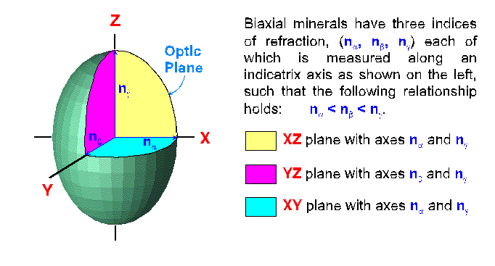
- n_{alpha} plotted along X
- n_{beta} plotted along Y
- n_{gamma} plotted along Z
again, n_{alpha} < n_{beta} < n_{gamma}
So that the length of X<Y<Z.
Indicatrix is a triaxial ellipsoid elongated along the Z axis, and flattened along the X axis.
Indicatrix has 3 principal sections, all ellipses:
- X - Y axes = n_{alpha} & n_{beta}
- X - Z axes = n_{alpha} & n_{gamma}
- Y - Z axes = n_{beta} & n_{gamma}
Random sections through the indicatrix also form ellipses.
The uniaxial indicatrix exhibited a single circular section, a biaxial indicatrix exhibits two circular sections with radius = n_{beta}; the circular sections intersect along the Y indicatrix axis, which also has a radius of n_{beta}.

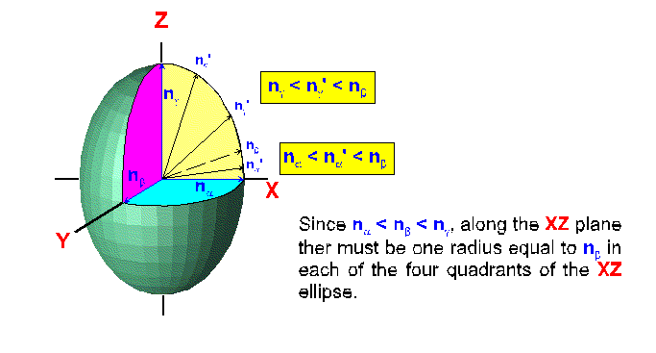
Look at the X - Z plane in the above image.
The axes of the ellipse are = n_{alpha} & n_{gamma}.
The radii vary from n_{alpha} through n_{beta} to n_{gamma}.
Remember that n_{alpha} < n_{beta} < n_{gamma}, so a radii = n_{beta} must be present on the X - Z plane.
The length of indicatrix along the Y axis is also n_{beta}, so the Y axis and radii n_{beta} in X - Z plane defines a circular section, with radius n_{beta}.

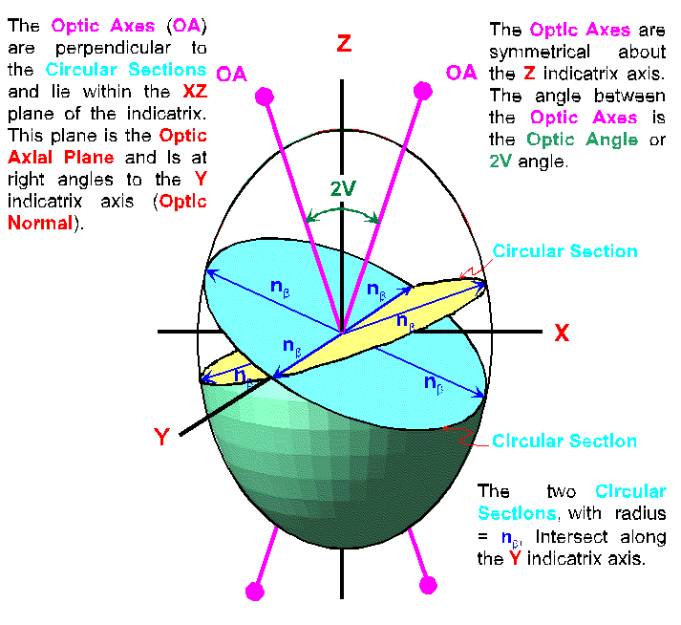
In the biaxial indicatrix the directions perpendicular to the circular sections define the OPTIC AXES of the biaxial mineral. Optic axes lie within the X - Z plane, and this plane is the OPTIC PLANE.
The acute angle between the optic axes is the optic or 2V angle.
The indicatrix axis, either X or Z, which bisects the 2V angle is the ACUTE BISECTRIX or Bxa.
The indicatrix axis, either X or Z, which bisects the obtuse angle between the optic axes is the OBTUSE BISECTRIX or Bxo.
The Y axis is perpendicular to the optic plane and forms the OPTIC NORMAL.

OPTIC SIGN
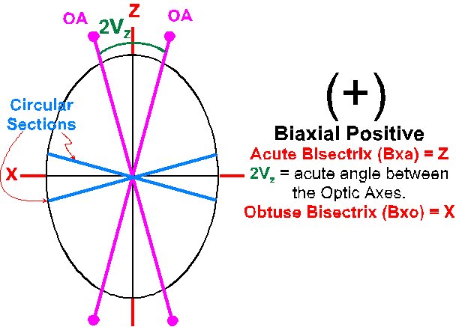
For biaxial minerals optic sign is dependant on whether the X or Z indicatrix axis is the acute bisectrix.
- if Bxa is X, mineral is -ve
- if Bxa is Z, mineral is +ve
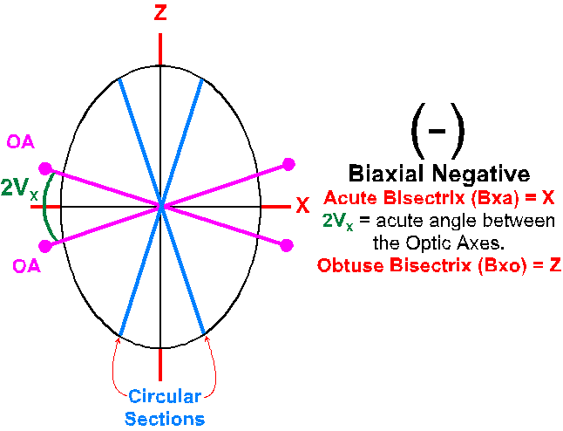
In the special case where 2V = 90°, mineral is optically neutral.
Another convention used is to identify the angle between the optic axes bisected by the X axis as the 2V_{X} angle; and the Z axis as 2V_{Z} angle.
These two angles can vary from 0 to 180°, such that the following relationship holds:
2V_{X} + 2V_{Z} = 180°
Using this convention the optic sign is determined by the following:
- if 2V_{Z} < 90°, the mineral is +ve.
- if 2V_{Z} > 90°, the mineral is -ve.

Light travelling through biaxial minerals is split into two rays - FAST and SLOW rays which vibrate at 90° to each other.
The vibration directions of the FAST and SLOW rays are defined, or determined, by the axes of the ellipse or section through the indicatrix, which is oriented at 90° to the wave normal.
The Refractive Index corresponding to the FAST ray will be between n_{alpha} and n_{beta}, and is referred to as n_{alpha}'.
The Refractive Index corresponding to the SLOW ray will be between n_{beta} and & n_{gamma}, and is referred to as n_{gamma}'.
With this convention the following relationship will be true for all biaxial minerals:
- X - will always correspond to the fast ray and will have the lowest RI.
  - RI = n_{alpha}, always fast
- Y - will be either the fast or the slow ray depending on which other indicatrix axis it is withand its refractive index will be between the lowest and highest RI for the mineral.
  - RI = nbeta, either fast or slow
- Z - will always correspond to the slow ray and will have the highest RI.
  - RI = n_{gamma}, always slow.

CRYSTALLOGRAPHIC ORIENTATION AND THE INDICATRIX
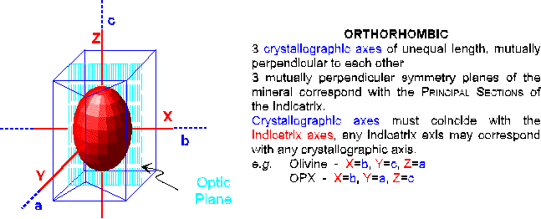

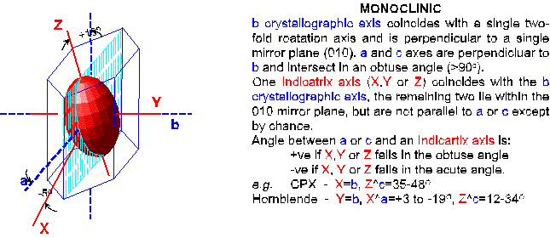

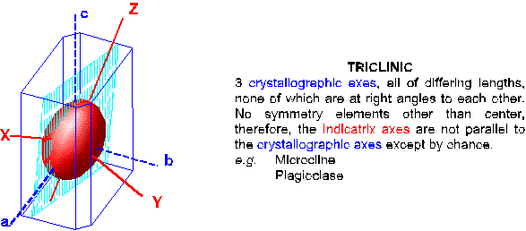

Biaxial Inteference Figures

INTRODUCTION
Biaxial interference figures are obtained the same way as uniaxial interference figures.
To obtain and observe an interference figure using the microscope.
- With high power, focus on a mineral grain free of cracks and inclusions
- Flip in the auxiliary condensor and refocus open aperture diaphragm up to its maximum.
- Cross the polars
- Insert the Bertrand lens or remove the ocular and look down the microscope tube.
Will not see the grain, but the interference figure, which appears on the top surface of the objective lense.
The appearence of the interference figure is dependant on the orientation of the mineral grain and its indicatrix.
We will examine 5 cases:
- Centred Acute Bisectrix
- Centred Biaxial Optic Axis
- Centred Obtuse Bisectrix
- Centred Optic Normal or Biaxial Flash Figure
- Random Orientations

ACUTE BISECTRIX FIGURE (Bxa)
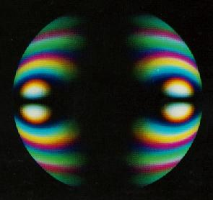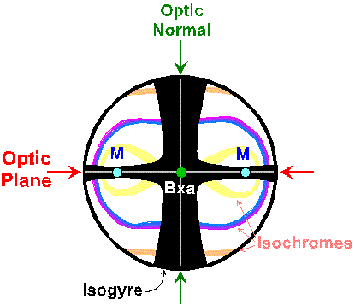
The Centred Bxa Figure, pictured in the images above, is obtained when the acute bisectrix is oriented perpendicular to microscope stage. The left image is a view of an acute bisectrix figure from the microscope, the right image is a drawing of an acute bisectrix figure with its component parts labelled.
If the 2V angle of the mineral is low, than the melatopes lie within the field of view as the stage is rotated. The isochromes form an oval or figure 8 pattern around the melatopes, while the pattern of the isogyres changes as the stage is rotated.

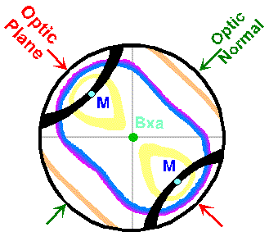
At extinction, left image above, the isogyres will form a cross with arms parallel with the crosshairs. On rotating the stage to the 45° position, right image above, the cross will split and the isogyres will form two hyperbole which will lie in opposite quadrants of the field of view. The melatopes and/or isogyres will always leave the field of view along the optic axial plane when the stage is rotated and the figure breaks up.

FORMATION OF THE ISOCHROMES
The isochromes form in the interference figure because they reflect varying degrees of retardation of the light.

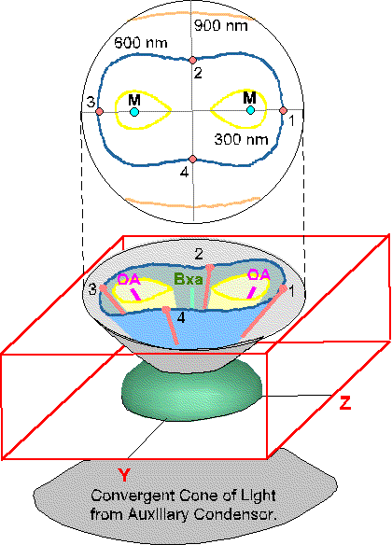
With the auxiliary condensor in place a strongly convergent cone of light is focussed into the mineral grain. Only light which follows one of the optic axes emerges from the grain with zero retardation.
This point is the MELATOPE (M), and there are two in biaxial minerals.
Light travelling along any other path through the mineral will exhibit varying degrees of retardation depending on the length of the path through the mineral and birefringence for that path.
The amount of retardation increases outward, ideally concentrically as seen in uniaxial minerals, from the melatope.
Near the melatope, the light experiences lower birefringence, travels a shorter distance through the mineral and therefore has a lower retardation.
Retardation increases slowly from melatopes towards the Actue Bisectrix (Bxa) (indicatrix axes).
The increased birefringence is partially compensated for by a shorter path.
The result is that the isochromes are stretched out towards Bxa, defining a tear drop shape or figure 8 pattern. The number of isochromes is dependant on:
- the partial birefringence experienced by the light, i.e.;
the difference between
  - n_{alpha} and n_{gamma} for biaxial positive minerals or
  - n_{beta} and n_{gamma} for biaxial negative minerals, and;
- the thickness of the crystal.

high birefringence & thick crystals = numerous isochromes

VIBRATION DIRECTIONS AND FORMATION OF THE ISOGYRES
The vibration directions of the light in the acute bisectrix interference figure can be derived in a similar manner to that used for uniaxial minerals. By taking a series of slices through the indicatrix, at right angles to the wave normals, we can determine the vibration directions for all paths of light emerging from the indicatrix.
The image below shows a biaxial negative indicatrix, X is the acute bisectrix, on which the vibration directions for the light are plotted as the blue lines on the surface of the indicatrix.
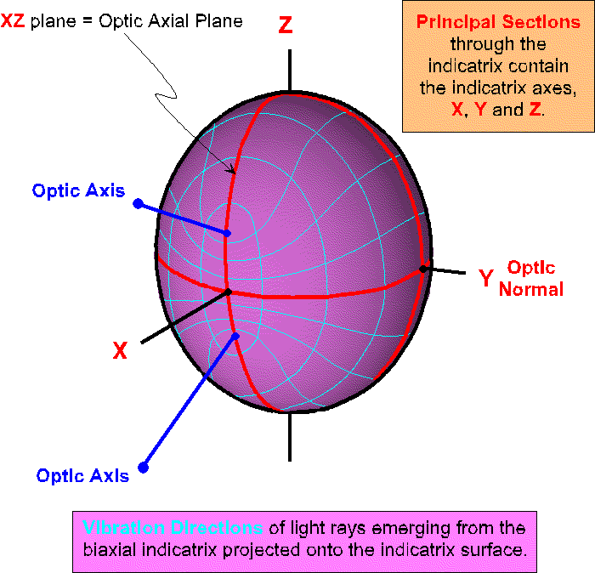

Since we are looking at the interference figure for the acute bisectrix, the indicatrix must be rotated so that the Bxa is vertical. This rotation causes the vibration directions to rotate as well. In the image below the indicatrix is shown, in grren, inside the mineral, and the vibration directions for the light are indicated, in blue, on the surface of the indicatrix.
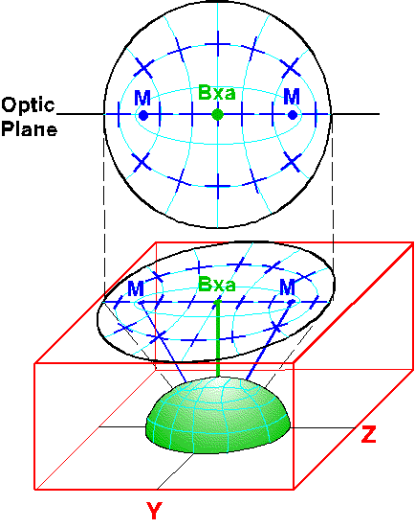
The vibration directions are projected onto the surface of the mineral and then onto the interference figure.
In the interference figure where the vibration directions through the mineral are parallel to the polarization directions of the microscope the resulting interference colour in the interference figure will be black - this is the isogyre. (I have not shown the isogyre in this image, so that the vibration directions of the light can be seen.)
On rotating the stage, the position of the vibration directions on the indicatrix surface will be rotated resulting in the change in the shape and movement of the isogyres in the interference figure.

ROTATION OF THE ISOGYRES
On rotating the stage, the shape and appearance of the isogyres change because the vibration directions for the light are also being rotated.
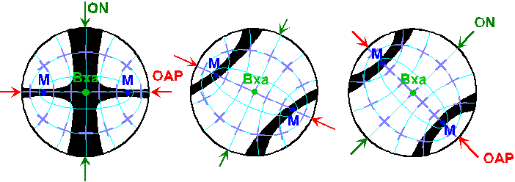
Rotation of the Isogyres, Bxa Figure, 2V < 40°.
When the grain is at extinction, and the acute bisectrix is vertical the interference figure will be centred in the field of view and will look like the left image above. In this orientation the optic plane (OAP) will be oriented either NS or EW, forming the thin arm of the isogyre cross. The arm of the cross which contains the optic plane also contains the melatopes (M). Near the melatopes the isogyres are at their narrowest.
The second arm of the isogyre cross, containing the optic normal (ON), is wider and fuzzier than the arm containing the optic plane.
Rotating the stage (center and right images above) causes the cross to split into two separate isogyres, with each isogyre pivoting about one melatope.
With the optic axis in the 45° position (right image above), the isogyres form two curved hyperbola with the melatopes acting as the vertices.
The isogyres are narrowest at the melatopes and thicken in both directions away from the melatope.
The isochrome pattern remains fixed relative to the position of the melatopes as the stage is rotated. The position and shape of the isochromes can be used to infer where the melatopes lie.
For minerals with a 2V angle of < 40°, the melatopes and isogyres will remain in the field of view as the stage is rotated.
For minerals with a 2V > 40° the position of both melatopes will lie outside the field of view when the interference figure is examined. The result is that at extinction the isogyre cross is visible, however on rotation the isogyres leave the field of view and are not visible in the 45° position, as the 2V angle is too large (> 40°). In this case the shape of the isochromes can be used to infer the position of the melatopes, the optic plane and the optic normal.
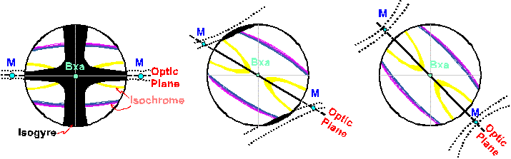
Rotation of the Isogyres, Bxa Figure, 2V > 40°
The 2V angle for a biaxial interference figure can be estimated by comparison of the image viewed under the microscope with Figure 7.32 (p. 103 in Nesse) or with the image below.
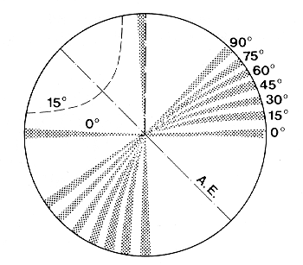

CENTRED OPTIC AXIS FIGURE

2V Angle < 30°
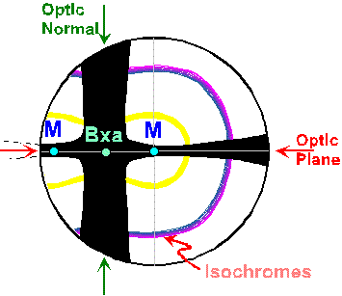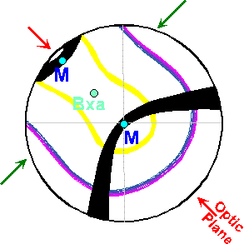
The Centred Optic Axis Figure is produced when 1 optic axis is vertical, and correspondingly the second optic axis and the bxa are inclined to vertical. See the block diagram below for the orientation of the indicatrix, the optic axes, Bxa, Bxo and the Optic Normal. The melatope corresponding to the vertical optic axis will be positioned directly beneath the crosshairs. This orientation is produced in a grain which displays the lowest interference colour for that mineral in the thin section being examined. WHY - light which travels along the optic axis sees the same electronic configuration in all directions yielding a single RI, and behaves as if it were travelling through an isotropic mineral.
At extinction the isogyre cross will be visible in the field of view, as shown in the left image above, if the 2V < ~ 30°, otherwise the center of the cross will lie outside the field of view. The center of the cross represents the position of the Bxa in the interference figure.
If the 2V is very small e.g., 1 - 5°, the interference figure looks like an off centred acute bisectrix figure.
Biaxial Optic Axis Figure (2V < 30°) Overhead

2V Angle > 50°
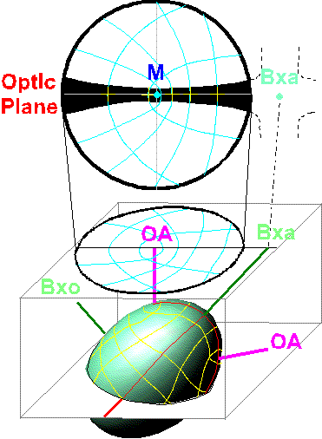
With a 2V > ~ 50° only one melatope with it's isogyre is visible within the field of view. The center of the cross representing the position of the Bxa will lie outside the field of view. With the mineral at extinction only a single arm of the cross, parallel to the crosshair, is visible and it narrows at the melatope. The optic plane of the indicatrix will lie along the isogyre and contains the melatope, in the field of view, and the Bxa and the second melatope, both of which lie outside the field of view.
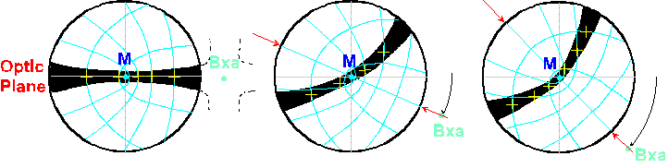
Rotating the stage clockwise causes the cross to break up, outside the field of view, and the isogyre pivots about the melatope in a counter-clockwise direction.
When the optic plane is NS or EW the isogyre is straight, forming one arm of the cross, and the mineral is at extinction.
With the optic plane in the 45° position the isogyre will show its maximum curvature and the position of the acute bisectrix lies on the convex side of the isogyre.
In this position the approximate 2V angle can be estimated using the figure below as a guide. A rule of thumb is that the straighter the isogyre, in the 45° position, the higher the 2V angle.

OBTUSE BISECTRIX FIGURE
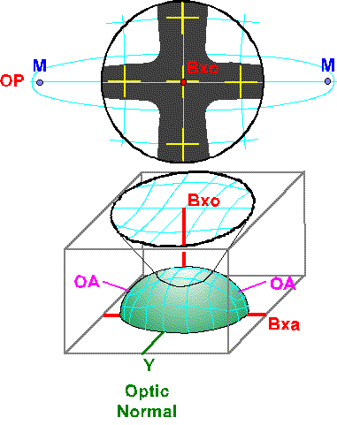
The Obtuse Bisectrix Interference Figure is produced when the obtuse bisectrix (Bxo) of the indicatrix is perpendicular to microscope stage.
The angle between the Bxo and the optic axes is > 45°. The result is that the melatopes will always lie outside the field of view.
The pattern of the isochromes and vibration directions are similar to those of Bxa figure, however the isogyre cross is generally fuzzier than Bxa figure. The optic plane will still parallel the EW or NS crosshair.
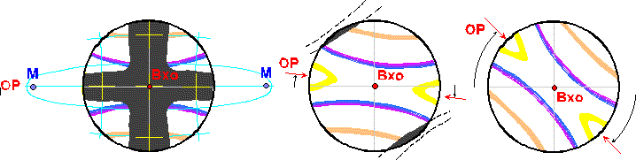
On rotating the stage the isogyre cross splits and leaves the field of view in the quadrants into which the optic plane (OP) is being rotated, as with Bxa figure.
The isogyre cross splits and leaves the field of view usually with a rotation of 5° to 15°.
For a Bxo figure the isogyres, when they split, will not be in the field of view.
If 2V = 90°, the Bxa and Bxo are identical, making the mineral optically neutral.
If 2V is small (~5° or less), the Bxo figure resembles an optic normal figure.

OPTIC NORMAL OR BIAXIAL FLASH FIGURE
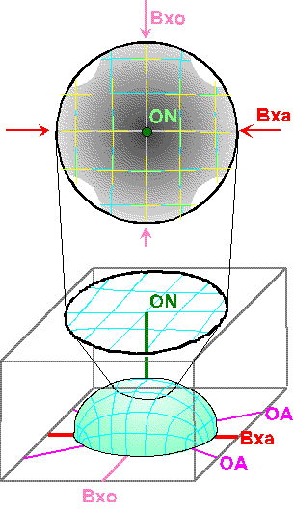
A biaxial optic normal figure is similar to the uniaxial flash figure, and is produced when the optic normal (ON) is vertical. In this orientation the optic plane, containing the Bxa, Bxo and optic axes, is horizontal.
The grain which produces this interference figure will display the maximum interference colour for this mineral in the thin section.
The vibration directions for the two rays exiting in figure are similar to those for a uniaxial flash figure.
When the X & Z indicatrix axes parallel the polarization directions, the flash figure is a broad fuzzy cross with only the outer edges of each quadrant of the field of view allowing some light to pass.
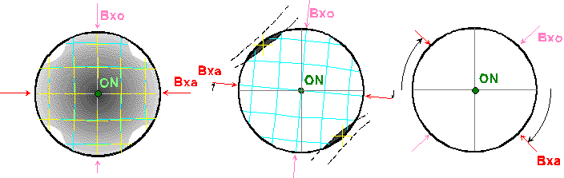
As with the uniaxial flash figure a very small rotation, < 5° of the stage causes the isogyre cross to split and leave the field of view in the quadrants into which the acute bisectrix is being rotated.
If 2V = 90° the cross - shaped isogyre does not split as the stage is rotated, it simply dissolves away, with a 5° rotation.

OFF CENTRED FIGURES
Most interference figures examined during routine microscope work are off-centred figures.
In these instances none of the indicatrix or optic axes is vertical.
Any combination of orientations is possible for off-centred figures.

Optic Sign Determination

CENTRED ACUTE BISECTRIX
In a centred acute bisectrix figure two rays of light propagate along the acute bisectrix which is either the X or Z indicatrix axis, and emerge in the centre of the Bxa interference figure, which is the point where the two isogyres cross.
At extinction the two rays vibrate parallel to the upper and lower polarizers forming the centre of cross.
- One ray vibrates parallel to the Y indicatrix axis and has an index of refraction equal to n_{beta}.
This ray orientation is also parallel to the optic normal, the Y indicatrix axis, and corresponds to the fatter arm of cross.
- The other ray vibrates parallel to the obtuse bisectrix of the indicatrix and has an index of refraction equal to n_{Bxo}.
This ray vibration direction is also parallel to the optic plane and corresponds to the thinner arm of cross. The optic plane contains the Bxa, Bxo and the melatopes.
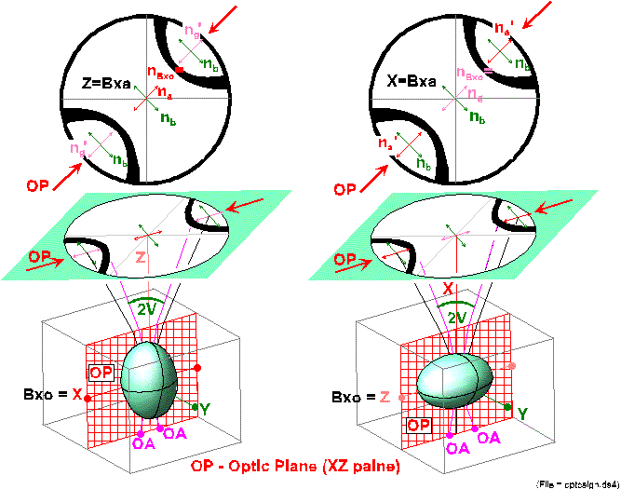
For optically positive minerals, the obtuse bisectrix is the X axis and n_{Bxo} = n_{alpha}, and corresponds to the fast ray, remember that (n_{alpha} < n_{beta} < n_{gamma}).
For optically negative minerals, obtuse bisectrix is the Z axis and n_{Bxo} = n_{gamma}, and corresponds to the slow ray.
Must determine whether the ray vibrating parallel to the obtuse bisectrix is the fast or slow ray.
To determine whether the X or Z axis is the acute bisectrix, and therfore whether the mineral is optically negative or positive, the interference figure must be rotated such that the optic plane is oriented NE-SW.
The steps to follow to determine the optic sign are:

Obtain an acute bisectrix interference figure.
Rotate the stage so that the trace of the optic plane is oriented NE-SW, i.e., the isogyre cross will split and move into the NE and SW quadrants.
  - if 2V angle is small, < ~40°, both isogyres will be visible in field of view.
  - if 2V angle is large, > ~40°, the isogyres will lie outside the field of view.

Insert accessory plate.
With the interference figure in the 45° position, the optic plane is oriented NE-SW, such that it is parallel with the slow vibration direction of the accessory plate. Observe the colour change that results.

Interpretation.

If the interference colours between the melatopes decrease the ray vibrating parallel to Bxo (parallel to optic plane) must be the fast ray so Bxo = X axis (X = fast ray) and Bxa, which is vertical, = Z axis. The mineral is optically positive.
If the interference colours between the melatopes increase, the ray vibrating parallel to Bxo must be the slow ray, so Bxo = Z axis, and Bxa = X axis. The mineral is optically negative.
If the trace of the optic plane is placed such that it lies in the NW-SE, the areas of addition and subtraction observed for the interference colours will be reversed.
If the interference figure displays few to no isochromes use the gypsum plate to determine the optic sign.
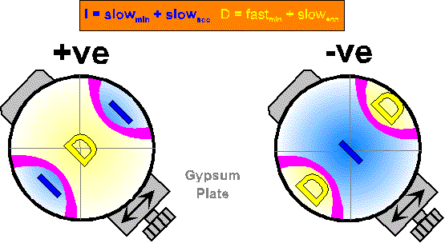
With the gypsum plate inserted the area between the isogyres will exhibit either:
- A decrease in colours, from white to yellow, (shown on the left above) indicates that the vibration direction in the interference figure, which is parallel to the optic plane is the FAST RAY. This colour change tells us that the ray which is vibrating parallel to the optic plane has a low index of refraction and must correspond to n_{alpha} as measured along the X indicatrix axis. Therefore the Z indicatrix axis must be the Bxa.
- An increase in colours, from white to blue, (shown on the right above) indicates that the vibration direction in the interference figure, which is parallel to the optic plane is the SLOW RAY. This colour change tells us that the ray which is vibrating parallel to the optic plane has a high index of refraction and must correspond to n_{gamma} as measured along the Z indicatrix axis. Therefore the X indicatrix axis must be the Bxa.

If there are numerous isochromes use the quartz wedge and watch the directions in which the isochromes move with respect to the isogyres, as the wedge is inserted.
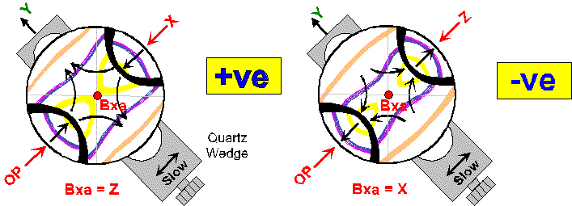
With insertion of the quartz wedge into the light path, the isochromes will move.
- Where colours increase, i.e. where the slow ray of the mineral is parallel with the slow ray of the wedge, the isochromes will move into the figure towards the melatopes, to be replaced by higher order colours from the edge of the figure.
- Where the colours decrease, i.e. where the fast ray of the mineral is parallel with the slow ray of the wedge, the isochromes will move out of the figure away from the melatopes, to be replaced by lower order colours.

CENTERED OBTUSE BISECTRIX
The obtuse bisectrix figure can be interpreted in the same way as the acute bisectrix, except that the trace of the optic plane has an index of n_{Bxa} rather than n_{Bxo}.
In the obtuse bisectrix figure if this ray, parallel to optic plane, is the fast ray than the acute bisectrix is the X axis.
- The mineral is optically negative.
In the obtuse bisectrix figure if this ray, parallel to optic plane, is the slow ray, then Bxa = Z axis.
- The mineral is optically positive.
The optic plane will lie in those quadrants of the field of view into which the isogyres move as the stage is rotated. These quadrants will also be those from which the isogyres leave the field of view.
If the 2V is large, e.g. 80 to 90°, it is difficult to distinguish the Bxa figure from the Bxo figure. The sign determination is impractical and a new grain, which produces an optic axis figure, i.e. one with the lowest interference colour, should be selected.

OPTIC AXIS FIGURE
If both melatopes lie in the field of view, an optic axis figure can be treated as an off centered acute bisectrix figure and the optic sign can be determined using the method outlined previously.
If only a single melatope is visible, when the interference figure is obtained, then it can be considered to be half of a Bxa figure. With a single melatope the convex side of the isogyre will point towards the location of the acute bisectrix, when the trace of the optic plane is oriented in 45° position.
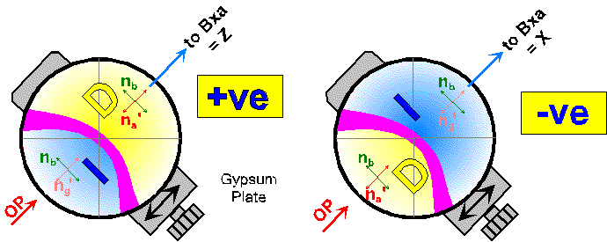
The isogyre will be curved in this position and the degree of curvature is a direct reflection of the amount of the corresponding 2V angle.
If 2V = 90°, the degree of curvature is difficult to determine. The isogyre appears as a straight line parallel to the crosshair when the grain is at extinction. It may be confused with an off-centred uniaxial optic axis figure, however when the stage is rotated the biaxial interference figure isogyre will also rotate while the unixial figure isogyre will move parallel to the crosshairs.
In this case the mineral is optically neutral and the sign is neither positive nor negative, and with 2V for the mineral = 90°.

OPTIC NORMAL OR BIAXIAL FLASH FIGURE
The optic normal or biaxial flash figure is not useful for determining optic sign, because the 2V cannot be determined and it cannot be distinguished from a uniaxial flash figure.
Estimates of 2V angles can be obtained from a centred Bxa figure, for 2V < 40°, and from a centred optic axis figure for 2V = 0 to 2V = 90°, (See Figure 7.32. in Nesse).

WHICH GRAINS ARE SUITABLE TO PRODUCE USABLE INTERFERENCE FIGURES?
As with uniaxial minerals, grains which will produce a centred to offcentred biaxial optic axis figure are easiest to identify because of their low interference colours due to the optic axis being vertical.
If the birefringence for the mineral is low, grains with their optic axis vertical will remain extinct or nearly extinct as the stage is rotated.
Optic axis figures are used for most routine work because these orientations produce interference figures where the both the optic sign and the 2V angle can be determined.
Optic normal figures (flash figures) have the Y indicatrix axis vertical and X and Z axes horizontal.
In this orientation, birefringence is at a maximum (n_{gamma} - n_{alpha}), and this orientation will also display the highest interference colour for that mineral in the thin section being examined. This interfernce figure is not useful for determiningthe 2V or the optic sign of the mineral.
The location and identification of grains which will produce an acute bisectrix figure is a matter of trial and error. Many grains and their interference figures must be examined before one with a nearly vertical Bxa is obtained.
The interference colour for this section will be in the lower range of that displayed for the mineral in the sample. Reason: birefringence for this orientation must be less than:
(n_{gamma} - n_{alpha}) /2
It is very time consuming to search for a suitable grain which will produce a centred Bxa figure, but it is essential because these figures give a better estimate of 2V than optic axis figures.
Locating grains which produce an obtuse bisectrix figures is again a trial and error procedure. Birefringence is higher than that exhibited for a grain producing a Bxa figure but less than a grain producing an optic normal figure. The result is that the interference colour will be in the upper portion for that exhibited by the mineral in the thin section.

OPTICAL PROPERTIES OF BIAXIAL MINERALS

Pleochroism
To completely describe the pleochroism of biaxial minerals it is necessary to specify 3 colours, each of which corresponds to the light vibrating parallel to one indicatrix axis.
For example in hornblende the pleochroism may be described as:
- X = yellow
- Y = pale green
- Z = dark green
The steps to be followed for determining the pleochroic scheme for biaxial minerals are outlined on p. 101 of Nesse. To record the pleochroic scheme for a biaxial mineral requires that you obtain two centred interference figures, e.g. a Bxa and an Optic Normal, and determine the vibration directions in each and then the associated colour for each indicatrix axis.

Extinction
The type of extinction (parallel, inclined symmetrical) observed for biaxial minerals is a function of cleavage and crystal habit for the minerals.
We will examine the types of extinction for various minerals when discussing one presenting characteristics later.

Sign of Elongation
The sign of elongation is dependent on which indicatrix axis is closer to the long dimension of the elongate mineral, grain or fragment.
- if the X indicatrix axis is parallel to the length - the mineral is length fast
- if the Z indicatrix axis is parallel to the length - the mineral is length slow
- if the Y indicatrix axis is parallel to the length, the mineral is either length fast or length slow depending on whether X or Z is in the plane of the section with Y.

Indices of Refraction
To determine the indices of refraction for biaxial minerals you must measure three different indices (n_{alpha}, n_{beta}, n_{gamma}) to fully describe a biaxial minerals.
This is done using grain mounts, and a procedure similar to that used for isotropic and uniaxial minerals, but is very time consuming.
It is not possible to measure the indices of refraction in a thin section, but comparison of the unknown mineral to other known minerals, whose incices are known, will provide an estimate of the relative indices for the unknown.

Dispersion in Biaxial Minerals
The refractve indices, n_{alpha}, n_{beta}, and n_{gamma}, for biaxial minerals vary for different wavelengths of light. As a result the value for the 2V angle and the orientation of the indicatrix for a given mineral will vary with the wavelength of light.
The variation in the size of the 2V angle is called optic axis dispersion.
The variation in the orientation of the indicatrix is referred to as indicatrix or bisectrix dispersion.
Dispersion is visible as colour fringes developed along the isogyres of the interference figure. Depending on the intensity of the colour fringes, the dispersion is weak, moderate or strong.
Read section on Dispersion in Orthorhombic, Monoclinic and Triclinic Minerals, p. 106.

We know want to examine the optical properties for the major minerals or groups of minerals which you will be looking at in the remainder of the labs. The minerals are:

OLIVINE
General Formula:  (Fe,Mg)₂SiO₄ | Sample: PT-96 | System:  Orthorhombic
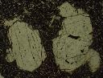 | 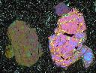 | 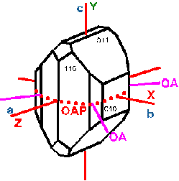
Euhedral to subhedral olivine phenocrysts, exhibiting irregular fractures, in a plagioclase microlite matrix  Field of View = 4.0 mm, plane light | Olivine phenocrysts exhibiting 2nd to 3rd order interference colours  Field of View = 4.0 mm, Crossed polars | Block diagram showing the relationship between the crystallographic axes and the indicatrix axes.

Optical Properties
Colour  Pleochroism | usually colourless, darker colours correspond to higher iron content  non pleochroic | Form | generally subequant anhedral grains or aggregates in intrusive and metamorphic rocks. Equidimensional or elongated euhedral grains in volcanics
Relief  RI | high positive  n_{α} = 1.636-1.827  n_{β} = 1.651-1.869  n_{γ} = 1.669-1.879 | Cleavage | not observed
Birefringence  Interference Colours | 0.033-0.052  up to third order | Twinning | not common
Interference Figure  Optic Sign  2V | biaxial  positive or negative  46-98° | Optic Orientation | elongate grains have parallel extinction and may be either length fast or slow
Composition | minor substitution of Mn, Zn, Ca, Ni, Cr or Al for Fe and Mg | Alteration | commonly alters to iddingsite and chlorophaeite, which are really mixtures of various minerals which cannot be identified, and serpentine. Alteration progresses from the edge and along cracks
Occurrence | pure Fo (Mg-rich) is restricted to metamorphosed carbonates, intermediate Fe-Mg olivine is common in mafic and ultramafic igneous rocks, Fe-rich olivine occurs in felsic rocks. | Distinguishing Features | high birefringence, distinctive fracturing, lack of cleavage, and alteration products.

ORTHOPYROXENE
General Formula:  (Mg,Fe)₂Si₂O₆ | Sample: W-3 | System:  Orthorhombic
 | 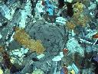 | 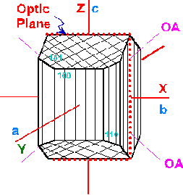
Orthopyroxene  The similar appearence in plane light of orthopyroxene and clinopyroxene are highlighted in this image. Note that both grains lack any clear colour, although coloured and pleochroic varieties are common.  Field of view = 4 mm, plane light | Orthopyroxene  The low interference colours characteristic of orthopyroxene compared to clinopyroxene are evident in this image.  Field of view = 4 mm, crossed polars | Block diagram showing the relationship between the crystallographic axes and the indicatrix axes.

Optical Properties
Colour  Pleochroism | pale coloured in thin section  with subtle pinkish to greenish pleochroism | Form | euhedral crystals are usually stubby prisms, basal sections are 4 or 8 sided, with two primatic cleavages at 90° longitudinal sections are rectangular, exhibit one cleavage and parallel extinction
Relief  RI | moderate to high  n_{alpha} = 1.649-1.768  n_{beta} = 1.653-1.770  n_{gamma} = 1.657-1.788  Generally increasing with increasing Fe content | Cleavage | two good cleavages parallel to the {210} prism faces that intersect at 88°
Birefringence  Interference Colours | 0.007-0.020  usually first order yellow or lower | Twinning | rare
Interference Figure  Optic Sign  2V | Biaxial  positive or negative  2V_{Z} = 50-132° | Optic Orientation | X=b, Y=a, Z=c  optic plane parallel to (100)  elongate fragments exhibit parallel extinction and are length slow
Composition | the effects of the substituion of Fe for Mg in orthopyroxene on the optical properties is evident in examining Figure 13.4 in Nesse. | Alteration | alters to serpentine, talc or fine grained amphibole
Occurrence | Mg-rich opx is common in mafic intrusive rocks (gabbro, norite, etc.). Fe-rich opx is found in more siliceous igneous rocks (diorite, syenite etc.).  opx is common in high grade regional metamorphic rocks | Distinguishing Features | distinguished from cpx by: 1) lower birefringence, 2) parallel extinction, 3) pale colour, weak pleochroism, 4) most common opx is optically negative, and 5) high 2V angle.

CLINOPYROXENE
General Formula:  (Ca,Mg,Fe,Al)₂(Si,Al)₂0₆ | Sample: AUPI 33 | System:  Monoclinic
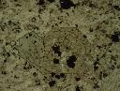 | 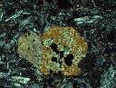 | 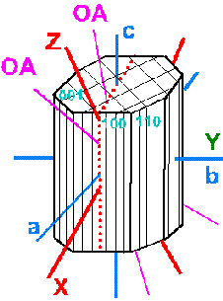
Clinopyroxene Phenocrysts  Euhedral, 8 sided, clinopyroxene phenocryst, exhibiting two cleavages, in a fine grained matrix of plagioclase microlites, clinopyroxene and olivine.  Field of view 2.7 mm, plane light | Clinopyroxene Phenocrysts  Note the black areas in the right grain due to plucking of the sample during preparation of the thin section.  Field of view 2.7 mm, crossed polars | Block diagram showing the relationship between the crystallographic axes and the indicatrix axes.

Optical Properties
Colour  Pleochroism | usually colourless, gray, pale green or pale brown, darker colours associated with Fe-rich varieties  Titanaugite is more distinctly coloured from brown/pink to violet. | Form | crystals form stubby prisms elongate along the c-axis, basal sections are 4 or 8 sided and show two cleavages at ~90°
Relief  RI | high positive  n_{alpha} = 1.664-1.745  n_{beta} = 1.672-1.753  n_{gamma} = 1.694-1.771 | Cleavage | typical pyroxene cleavages parallel to {110}, which intersect at ~90°
Birefringence  Interference Colours | 0.018-0.034  lower to middle second order | Twinning | simple and lamellar twins and composition planes, which in combination may form a herringbone pattern
Interference Figure  Optic Sign  2V | Biaxial  positive  25-70° | Optic Orientation | sections parallel to (100) show parallel extinction  sections parallel to (010) show maximum birefringence, a single cleavage and Z^c of 35 to 48°
Composition | All clinopyroxenes crystallize with the same structure and there is complete solid solution among all species and they cannot be distinguished reliably based on their optical properties | Alteration | commonly alter to uralite (a fg, light coloured amphibole), or may alter to serpentine, chlorite, biotite, carbonates and /or other silicates
Occurrence | common in mafic igneous rocks, alkali-rich varieties may be found in more silicic rocks, often associated with olivine, orthopyroxene, and plagioclase | Distinguishing Features | inclined extinction, higher birefringence, 2nd order interference colours, low 2V, optically positive in comparison with opx

HORNBLENDE
General Formula:  (Na,K)₀₋₁Ca₂(Mg,Fe²⁺,Fe³⁺,Al)₅(Si,Al)₈O₂₂(OH)₂ | Sample: AUPI-37 | System:  Monoclinic
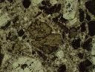 | 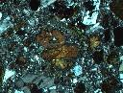 | 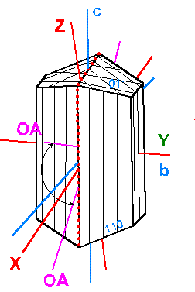
Euhedral Hornblende Phenocrysts  Numerous hornblende phenocrysts, exhibiting a range of pleochroic colours, euhedral shapes and two cleavages which intersect at 56-124°:.  Field of View = 2.7 mm, plane light | Euhedral Hornblende Phenocrysts  Note that the interference colour exhibited by the individual hornblende grains is masked to some degree by the dark colour of the grain.  Field of view = 2.7 mm, crossed polars | Block diagram showing the relationship between the crystallographic axes and the indicatrix axes.

Optical Properties
Colour  Pleochroism | distinctly coloured, shades of green, yellow-green, blue-green and brown  X = light yellow, light yellow green, light blue green  Y = green, yellow green, gray-green, brown  Z = dark green, dark blue-green, dark gray-green, dark brown | Form | found as slender prismatic to bladed crystals, with a 4 or 6 sided cross section which exhibit amphibole cleavage at 56 and 124°, also as anhedral irregular grains
Relief  RI | moderate to high  n_{alpha} = 1.60-1.70  n_{beta} = 1.61-1.71  n_{gamma} = 1.62-1.73 | Cleavage | amphibole cleavages on {110} intersect at 56-124° fragment shape is controlled by cleavage
Birefringence  Interference Colours | 0.014-0.034  usually upper first or lower second order, but may be masked by mineral colour | Twinning | simple and lamellar twins on {100} are not uncommon
Interference Figure  Optic Sign  2V_{X} | biaxial  positive or negative  35 - 130° | Optic Orientation | X^a = +3 to -19°, Y = b, Z^c = +12 to +34°, optic plane = (010)  basal sections exhibit symmetrical extinction with the slow ray parallel to the long diagonal between the cleavages, longitudinal sections are length slow
Composition | exhibits a wide range of compositions | Alteration | may be altered to biotite, chlorite or other Fe-Mg silicates
Occurrence | common mineral found in a variety of geological environments, i.e. in igneous, metamorphic and sedimentary rocks | Distinguishing Features | cleavage and grain shape, inclined extinction, pleochroism

ACTINOLITE-TREMOLITE
General Formula:  Ca2(Mg,Fe²⁺)₅Si₈O₂₂(OH)₂ | Sample: M-14 | System:  Monoclinic
 | 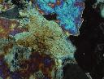
Actinolite  Low to medium grade amphibolite consisting essentailly of actinolite-tremolite. The large grain in the centre of the image displays two cleavages which intersect at 56 - 124°.  Field of view 2.7 mm, plane light | Actinolite  Low to medium grade amphibolite, notet the range of interference colurs displayed by the actinolite in the image.  Field of view 2.7 mm, crossed polars | Block diagram showing the relationship between the crystallographic axes and the indicatrix axes.

Optical Properties
Colour  Pleochroism | colourless to pale green to dark green, darker colours and stronger pleochroism associated with high Fe contents  X = colourless, pale yellow green  Y = pale yellow-green, pale blue-green  Z = pale green, green, blue-green | Form | occurs as columnar, bladed or acicular grains, elongated parallel to c axis, may be fibrous, basal sections are diamond shaped, with typical amphibole cleavage
Relief  RI | moderate to high positive  n_{alpha} = 1.599-1.688  n_{beta} = 1.612-1.697  n_{gamma} = 1.622-1.705 | Cleavage | two amphibole cleavages on {110}, intersect at 56 and 124°
Birefringence  Interference Colours | 0.017-0.027  maximum interference colours are upper 1st to mid 2nd order | Twinning | simple and lamellar twins
Interference Figure  Optic Sign  2V | biaxial  negative  2V_{X} = 75-88° | Optic Orientation | X ^ a = +5° to -6°  Y = b,  Z ^ c = +10° to +21°  optic plane = (010)  elongate sections are length slow
Composition | the primary compositional variation is the relative proportion of Fe²⁺ and Mg | Alteration | alters to talc, chlorite and carbonates
Occurrence | common occurrence is in contact and regional metamorphosed limestone and dolomite. Also found in metamoprhosed mafic and ultramafic rocks. It is the common fine-grained alteration product of pyroxenes. | Distinguishing Features | actinolite closely resembles hornblende, however the latter usually has a smaller 2V angle and may have a higher extinction angle.

PLAGIOCLASE
General Formula:  NaAlSi₃O₈-CaAl₂Si₂O₈ | Sample: PT-10C | System:  Monoclinic
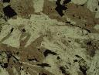 |  | 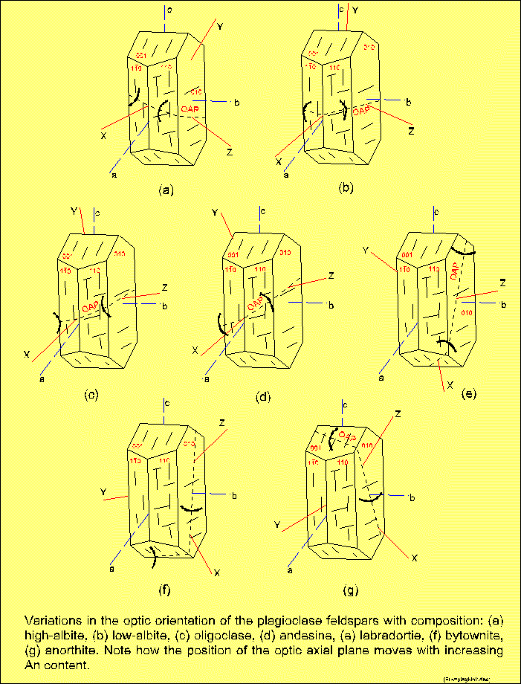
Ophitic Texture  Colourless plagioclase grains, note cleavage to right of label, surrounded by a large oikocryst of clinopyroxene  Field of View = 4 cm, plane light | Ophitic Texture  Albite, pericline and Carlsbad twinned plagioclase grains enclosed within a second order green clinopyroxene.  Field of View = 4 cm, crossed polars | The above image presents a series of block diagrams showing the variation in indicatrix axes and crystallographic axes position with composition.

Optical Properties
Colour  Pleochroism | colourless  non-pleochroic | Form | occurs as both euhedral and anhedral grains; crystals are tabular parallel to (010), i.e. lath shaped, and elongated parallel to the c or a axis. Chemical zoning is common and is expressed as a variation in the extinction angle from one zone to another.
Relief  RI | low positive or negative, dependant on composition n_{alpha} = 1.527 - 1.577  n_{beta} = 1.531 - 1.585  n_{gamma} = 1.534 - 1.590 | Cleavage | {001} perfect cleavage, {010} good cleavage. The cleavages intersect at 93° to 94°.
Birefringence  Interference Colours | 0.007-0.013  first order grey or white | Twinning | polysynthetic twinning is characteristic. Common twin laws are:  - albite (010) composition plane, polysynthetic, found in all compositions  - pericline: (h01) composition plane, polysynthetic, found in intermediate to calcic compositions  - Carlsbad: (010) composition plane, penetration, found in intermediate to calcic compositions
Interference Figure  Optic Sign  2V | biaxial  positive or negative  varies systematically with composition | Optic Orientation | Optic orientation varies in a regular manner with composition. Except by chance none of the indicatrix axes coincides with any of the crystallographic axes.
Composition | plagioclase shows continuous solid solution from albite to anorthite with NaSi replacing CaAl. | Alteration | commonly partially altered to sericite, clay or zeolites. Plagioclase also may alter to saussurite, a fine grained aggregrate of epidote group minerals, albite, sericite and other minerals.
Occurrence | widespread mineral found in nearly all igneous rocks, in many metamorphic rocks and some sediments. The composition of igneous plagioclase will reflect the composition of the melt from which the mineral formed. | Distinguishing Features | low relief, colourless, biaxial figure, polysynthetic twinning.

BIOTITE
General Formula:  K₂(Mg,Fe)₃AlSi₃O₁₀(OH,O,F₂)₂ | Sample: PT-104 | System:  Monoclinc
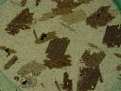 | 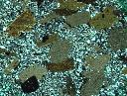 | 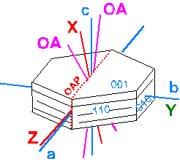
Biotite Porphyrobalsts  Randomly oriented biotite porphyroblasts, exhibiting a range of pleochroic colours, in a pelite collected from the Meguma Group, Nova Scotia. Note the higher relief garnet grain in the lower left corner  Field of view = 4 mm, plane light | Biotite Porphyroblasts  The biotite porphyroblasts display a range of interference colours, and "bird's eye" extinction where the cleavge traces are parallel or nearly parallel to the polars (NS and EW).  Field of view = 4 mm, crossed polars | Block diagram showing the relationship between the crystallographic axes and the indicatrix axes.

Optical Properties
Colour  Pleochroism | typically brown, browhish green or reddish brown  distinctly pleochroic | Form | tabular crystals parallel to {001} with a rough hexagonal shape, also as micaceous or tabular grains or grains with irregular outlines
Relief  RI | moderate to moderately high positive  n_{alpha = 1.522-1.625}  n_{beta = 1.548-1.672}  n_{gamma = 1.549-1.696} | Cleavage | perfect cleavage on {001}
Birefringence  Interference Colours | 0.03-0.07  up to third or fourth order, a strong mineral colour may mask the interference colour | Twinning | rarely visible
Interference Figure  Optic Sign  2V | biaxial  negative  0-25° | Optic Orientation | extinction is parallel or nearly parallel, with a maximum extinction angle of a few degrees. Cleavage traces are length slow.
Composition | variable composition | Alteration | alters to chlorite, clay minerals, and/or sericite, iron-titanium oxides, epidote, calcite, and sulphides
Occurrence | common in a wide range of igneous and metamorphic rocks and may be an important detrital mineral in sediments | Distinguishing Features | colour, pleochroism, "birds-eye" extinction, nearly parallel extinction

MUSCOVITE
General Formula:  KAl₂(Al,Si₃O₁₀)(OH)₂ | Sample: PT-51 | System:  Monoclinic
 | 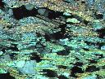 | 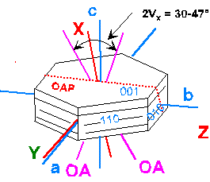
Muscovite Flakes  Elongated, colourless flakes of muscovite, in a pelite from the Grenville Supergroup, Central Metasedimentary Belt of the Grenville Province.  Field of view = 2.7 mm, plane light | Muscovite Flakes  The flakes of muscovite display the characteristic second order blue interference colour. Note that the muscovite flakes define the fabric in the sample, with all exhibiting an EW orientation.  Field of view = 2.7 mm, crossed polars | Block diagram showing the relationship between the crystallographic axes and the indicatrix axes.

Optical Properties
Colour  Pleochroism | colourless  non pleochroic | Form | found as micaceous flakes or tablets with irregular outlines
Relief  RI | moderate positive  n_{alpha} = 1.552-1.580  n_{beta} = 1.582-1.620  n_{gamma} = 1.587-1.623 | Cleavage | perfect on {001}
Birefringence  Interference Colours | 0.036-0.049  vivid second order blues and greens | Twinning | rare
Interference Figure  Optic Sign  2V | biaxial  negative  30-47° | Optic Orientation | parallel extinction, cleavage traces are length slow
Composition | highly variable | Alteration | not generally altered
Occurrence | common in a wide variety of metamorphic rocks, felsic igneous rocks and as detrital grains in sedimentary rocks | Distinguishing Features | colourless, parallel extinction, "birds-eye" extinction

CHLORITE
General Formula:  (Mg,Fe,Al)₃(Si,Al)₄O₁₀(OH)₂*(Mg,Fe,Al)₃(OH)₆ | Sample: PT-115D | System:  Monoclinic and Triclinic
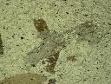 |  | 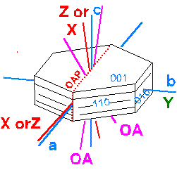
Chlorite Porphyroblast  A relict chlorite porphyroblast within a Meguma Group pelite, from Nova Scotia. Note the very weak colour visible in plane light.  Field of view = 2.7 mm, plane light | Chlorite Porphyroblast  The interference colour displayed by the chlorite is masked to some degree by the colour of teh grain.  Field of view = 2.7 mm, crossed polars | Block diagram showing the relationship between the crystallographic axes and the indicatrix axes.

Optical Properties
Colour  Pleochroism | light to medium green  pleochroic, expressed in shades of green, darker varieties are Fe-rich | Form | commonly found as plates similar to micas
Relief  RI | moderate to moderately high positive  n_{alpha} = 1.55-1.67  n_{beta} = 1.55-1.67  n_{gamma} = 1.55-1.69 | Cleavage | perfect on {001}
Birefringence  Interference Colours | 0.0-0.015  first order white to yellow, may exhibit anomalous blue or purplish interference colours | Twinning | none
Interference Figure  Optic Sign  2V | biaxial  positive or negative  0-60° (positive)  0-40° (negative) | Optic Orientation | extinction angle up to 9°, cleavage trace in optically positive varieties is length fast and in optically negative varieties is length slow
Composition | highly variable | Alteration | oxidation may produce iron stains, but chlorite is relatively stable.
Occurrence | widespread mineral in contact and regional metamorphic rocks of low grade, as an alteration product of mafic minerals in igneous rocks | Distinguishing Features | colour, weak pleochroism, and weak birefringence

MICROCLINE
General Formula: | KAlSi₃O₈ | System: Triclinic
 | 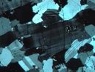 | 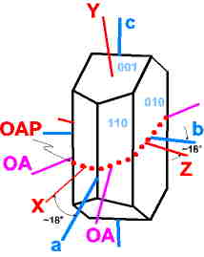
TITLE  DESCRIPTION  SCALE | TITLE  DESCRIPTION SCALE | Block diagram showing the relationship between the crystallographic axes and the indicatrix axes.

Optical Properties
Colour  Pleochroism | colourless  non pleochroic | Form | Anhedral to euhedral in many igneous and metamorphic rocks
Relief  RI | Low negative  n_{alpha} = 1.514 - 1.526  n_{beta}= 1.518 - 1.530  n_{gamma} = 1.521 - 1.533 | Cleavage | Perfect parallel to {001}  Good parallel to {010}  Cleavages intersect at 90°41’
Birefringence  Interference Colours | 0.005 – 0.008  No higher than first order yellow | Twinning | Distinctive cross hatched or ‘tartan plaid’ twinning
Interference Figure  Optic Sign  2V | Biaxial  Negative  65 – 88° | Optic Orientation | Optic plane parallel to (001)  X^a ~18°, Y^c ~ 18°, Z^b ~18°  Extinction is inclined to cleavage
Composition | Data | Alteration | Alters to sericite and clay minerals
Occurrence | Found in granite, granodiorite, pegmatite, syenite and related plutonic rocks. Not normally found in volcanic rocks.  Common in regional metamorphic rocks of fairly high grade.  Common in immature clastic rocks. | Distinguishing Features | Tartan plaid twinning.

ORTHOCLASE
General Formula: | KAlSi₃O₈ | System: Monoclinic
 |  | 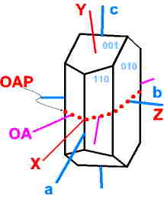
 |  | Block diagram showing the relationship between the crystallographic axes and the indicatrix axes.

Optical Properties
Colour  Pleochroism | colourless  non pleochroic | Form | Common as anhedral to euhedral grains in igneous rocks.
Relief  RI | Low negative  n_{alpha} = 1.514 - 1.526  n_{beta}= 1.518 - 1.530  n_{gamma} = 1.521 - 1.533 | Cleavage | Perfect parallel to {001}  Good parallel to {010}  Cleavages intersect at 90°
Birefringence  Interference Colours | 0.005 – 0.008  No higher than first order white | Twinning | Range of twins may be present, eg. Carlsbad, Baveno, Mandebach.  Polysynthetic twins, as in plagioclase and microcline are not found.
Interference Figure  Optic Sign  2V | Biaxial  Negative  40 – ~70° | Optic Orientation | Optic plane is perpendicular to (010) and inclined between 5° and 13° to (001).  X^a = +5° to +13°, Y^c = + 21° to 13°, Z=b  Extinction is inclined to cleavage
Composition | Data | Alteration | Alters to clay minerals and sericite
Occurrence | Widespread in granite, granodiorite, pegmatite, syenite and related felsic rocks, emplaced at shallow depths.  Sanidine is more common in volcanic rocks and microcline more common in deep seated intrusives.  Common in contact and regional metamorphic rocks.  As a detrital grain in clastic sediments. | Distinguishing Features | Distinguished from sanidine based on 2V and from microcline by the lack of tartan twinning.

SANIDINE
General Formula: | (K,Na)AlSi₃O₈ | System: Monoclinic
 |  | 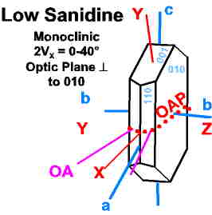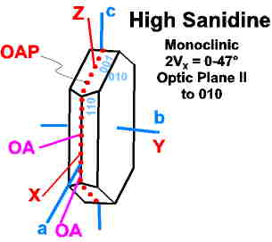
 |  | Block diagram showing the relationship between the crystallographic axes and the indicatrix axes.

Optical Properties
Colour  Pleochroism | colourless  non pleochroic | Form | Common as phenocrysts or tabular crystals
Relief  RI | Low negative  n_{alpha} = 1.514 - 1.526  n_{beta}= 1.518 - 1.530  n_{gamma} = 1.521 - 1.533 | Cleavage | Perfect parallel to {001}  Good parallel to {010}  Cleavages intersect at 90°
Birefringence  Interference Colours | 0.005 – 0.008  No higher than first order white | Twinning | Carlsbad twins with a composition plane parallel to (010), dividing the crystal into two segments.
Interference Figure  Optic Sign  2V | Biaxial  Negative  2V_{X} = 0–40° (Low Sanidine)  2V_{X} = 0–47° (High Sanidine) | Optic Orientation | Two Orientations possible:  High Sanidine:  Optic plane is parallel to (010)  X^a = ~+5°, Y=b, Z^c = + 21°  Low Sanidine:  Optic plane is perpendicular to (010)  X^a = +5° to 9°, Y^c = + 21° to +17°, Z=b  Extinction is inclined to cleavage
Composition | Data | Alteration | Alters to clay minerals and sericite
Occurrence | Common K-feldspar in silicic volcanic rocks, eg. rhyolite, rhyodacite, phonolite and trachyte and in dykes of shallow intrusives. May occur in high temperature contact metamorphic rocks. | Distinguishing Features | Low Sanidine is distinguished from morthoclase by a smaller 2V_{X} angle.  High Sanidine is distinguished from low Sanidine and orthoclase by the orientation of the optic plane.

RECOGNITION AND DESCRIPTION OF MINERALS
By this point in the course you are familiar with the following minerals which make up the majority of those present in igneous, metamorphic and sedimentary rocks.

ISOTROPIC MINERALS
Halite | NaCl
Fluorite | CaF₂
Periclase | MgO
Garnet | (Ca,Mg,Fe²⁺,Mn)₃ (Al,Fe³⁺,Cr)₂(SiO₄)₃

UNIAXIAL MINERALS
Quartz | SiO₂
Calcite | CaCO₃
Nepheline | NaAlSiO₄
Apatite | Ca₅(PO₄)₃(F,Cl,OH)
Zircon | ZrSiO₄
Tourmaline | Boro-Silicate

BIAXIAL MINERALS
Olivine | (Mg,Fe)₂SiO₄
Orthopyroxene | (Mg,Fe)₂Si₂O₆
Clinopyroxene | (Ca,Mg,Fe,Al)₂Si₂O₆
Hornblende | Ca₂(Mg,Fe,Al)₅Si₈O₂₂(OH)₂
Plagioclase | (Na,Ca)Al(Al,Si)Si₂O₈
Alkali Feldspar | KAlSi₃O₈
Biotite | K₂(Mg,Fe)₃AlSi₃O₁₀(OH,F,O)₂
Muscovite | KAl₂(AlSi₃O₁₀)(OH)₂
Chlorite | (Mg,Al,Fe)₃(Si,Al)₄O₁₀(OH)₂*(Mg,Al,Fe)₃(OH)₆
Tremolite  Actinolite | Ca₂Mg₅Si₈O₂₂(OH)₂  Ca₂Fe₅Si₈O₂₂(OH)₂
The last half of the text is devoted to the description of the common minerals (200 or ~10% of those known minerals) found in most rocks. However, over 3,000 different minerals have been identified and any one or more of these may be present in a given thin section in amounts from 1-2% to a single grain.

What features may be used to aid in the identification of minerals within an individual thin section?

Shape of Crystal
 | acicular | needle-like grains (actinolite, tremolite)
 | bladed | elongate, slender (hornblende)
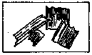 | columnar | elongate with equidimensional cross sections (qtz, pyroxenes)
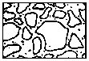 | equant | equidimensional grains (quartz, olivine)
 | fibrous | grains form long slender fibers (asbestos, sillimanite)
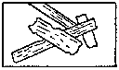 | lathlike | flat elongate grains (plagioclase)
 | prismatic | crystal faces defined by prism (apatite)
 | tabular | book shape (plagioclase)

Degree of Crystallinity
 | euhedral | grains have well formed crystal faces
 | subhedral | poorly formed and/or irregular crystal faces
 | anhedral | no regular crystal faces

Cleavage
In grain mounts, straight edges on grains generally indicate the presence of cleavage. In thin section, cleavage is difficult to recognize in minerals with a low relief, under normal circumstances, by closing the aperture diaphragm cleavage is more readily observed.
Grains at the edge of the thin section may exhibit cleavage more so than grains in the centre, as these grains will readily break along the cleavage planes as the thin section is being made.
The angle between cleavages is useful for identifying the broad mineral group to which the unknown belongs, e.g. if the grain exhibits two cleavages that intersect at 56 - 124° then the unknown belongs to the amphibole group.

Twinning
The presence and nature of the twins in a grain may be diagnostic for that mineral. A variety of common twins may be observed in thin section, with the type dependant on the individual mineral.
  - simple twins - two segments of one grain go extinct at different times as the stage is rotated.
  - contact twins - the segments are joined by a smooth twin plane separating the segments.
  - penetration twins - the segments are joined by an irregular contact.
  - polysynthetic twinning - consists of numerous twin segments joined on parallel twin planes.

5. Alteration
The type of alteration product observed within an individual grain may be used as an aid in identifying that grain, e.g.:
  - iddingsite alteration of olivine
  - sericite alteration of plagioclase
  - clay minerals from alkali feldspars

6. Associations
Knowing the common mineral associations in a variety of rock types may aid in making an "educated guess" as to the identity of an unknown mineral.
Knowing the association for a given rock may aid in the identification of a specific mineral which might otherwise have been overlooked.

